User Manual:

Barcode Sharp Shooter

| July-20 |

**Document Overview**

**Documentation Goals**

This documentation is intended to provide instruction for ***The Advantzware Barcode Sharp Shooter Program****.*

**Documentation Disclaimers**

* Teach a user how to utilize the different aspects of the Sharp Shooter system.
* Provide instructions scanning or manually entering new Raw Material and Finished Good receipts.
* Provide instructions scanning or manually entering Raw Material and Finished Good returns.
* Provide instructions scanning or manually entering Raw Material and Finished Good issues.
* Provide instructions scanning or manually entering Raw Material and Finished Good transfers.
* Provide instructions scanning or manually entering Raw Material and Finished Good physical counts.
* Provide instructions scanning or manually entering Raw Material and Finished Good deletions.
* Provide instructions scanning or manually entering Load Tags and Vendor Tags.

**Table of Contents**

**Overview of Advantzware Specific Keys and Icons** 5

Function Keys 5

Advanced Software Standard Function Keys 6

Program Icons 7

**Sharp Shooter Overview** 8

**Sharp Shooter Steps** 9

Standard Procedure for the Scanners Project 9

**Materials [BM]** 11

Overview 11

Receive Materials 13

Overview 13

Add/Update Transaction Receipt 14

Issue Materials 17

Overview 17

Add/Update Issue 19

Job Returns 23

Add Return 23

Transfer Materials 27

Overview 27

Add/Update Transfer 29

Move Materials 31

Update Material Receipts 31

Count Materials 34

Overview 34

Add Physical Count 35

Delete Materials 38

Add Deletion 38

Post Materials 42

Overview 42

Scan Vendor Tag 44

Overview 44

Browse Vendor Tags 45

**WIP Menu [BW]** 47

Overview 47

Main Menu 47

Work in Process Icons 48

WIP Create 49

Adjust Work in Process 51

WIP Issue 52

WIP Transfer 53

**Finished Goods [BF]** 54

Overview 54

Main Menu 55

Receive Goods 57

Overview 57

Add Receipt 59

Add/Update Set Parts 63

Move Receipts 67

Update Receipt 67

Transfer Goods 70

Overview 70

Add Transfer 71

Transferring Partial Quantity 73

Count Goods 74

Overview 74

Add/Update Count 75

Delete Goods 78

Add Receipt 79

Add/Update Set Parts 83

Return Goods 87

Add Return 88

Post Goods 91

Consolidate Tags 94

Add Finished Good Tags 95

**Bill of Lading Transaction [BB]** 97

Overview 97

Main Menu 97

Create BOL 98

Overview 98

Add BOL 98

Print BOL 100

Update Release 101

Print Pick Ticket 102

**Label Menu [BL]** 105

Overview 105

Make Finished Good Load Tags 106

Make Raw Material Tags 110

Overview 110

Scan Case Label 112

Overview 112

Add Case Label 112

File Maintenance 114

Overview 114

Finished Goods: View Load Tag 117

Finished Goods: Add/Update Load Tag 118

Raw Materials: View RM Load Tag 124

Raw Materials: Add/Update RM Load Tag 125

Case Label: View Case Label 129

Case Label: Add/Update Case Label 130

**Reports for Sharp Shooter Report [BR]** 134

Production Report [BR1] 134

**Sharp Shooter Inquiry [BQ]** 136

Job Attachments [BQ1] 136

# **Overview of Advantzware Specific Keys and Icons**

## Function Keys

|  |  |
| --- | --- |
| BRWS | The browser, which is a list of records in this file. This is functionally equivalent to the Find option of our standard package. |
| VIEW | View record provides the ability to ADD, CHANGE, DELETE, and UPDATE an individual record. |
| SORT BY | The selections at the bottom of the browser, which will sort the list alphabetic order. |
|  |  |
| Update | Update the current record. |
| Reset | Reset the current record. |
| Add | Add a record. |
| Copy | This will copy the existing record. |
| Delete | Delete the current record displayed on the screen. |
| Cancel | Cancel the information that was entered. |
| Save | Save the record. |
|  |  |
|  | Takes the user to the first current record. |
|  | Moves backward one record. |
|  | Moves forward one record. |
|  | Takes the user to the last current record. |
|  |  |
| F1 | Miscellaneous Fields |
| F3 | Search |
| F3 | List |
| F4 | Notes |
| F6 | Browse |
| F7 | Viewer |
| F12 | Exit |

## Advanced Software Standard Function Keys

|  |  |
| --- | --- |
| Next | Shows the next sequential record. |
| Prev | Shows the previous record. |
| Add | Add a record. |
| Change | Change the current record displayed on the screen. |
| Delete | Delete the current record displayed on the screen. |
| Find | Find a record by searching by description. |
| “1”, “2” | Number 1 or 2 to go the first or second page of this record. |
| Esc | Escape from the current transaction without updating. |
| Q | Quit from the current transaction without updating. |
| F1 | Save |
| F3 | Help information is available on every data field. Simply place the cursor on a field and press F3 to display documentation regarding this particular field. |
| F3 | To insert additional data in a data field without erasing the information currently displayed. |
| F4 | Notes – General |
| F1 | Field Lookup is available on every data field which is maintained in a separate file. Place the cursor on a field and press ***“F1”*** to search for the code by description or to advance a screen of records by pressing the next key. Place the cursor next to the desired record and press enter to transfer the record to the data entry screen. See ***“Page Up”*** / ***“Page Down”*** keys below as an alternative |
| F7 | Delete |
| F8 | Notes – File Specific |
| Enter | Advances the cursor to the next field |
| Page Up | Will skim forward through each record in a data file in sequential order |
| Page Down | Will skim backward through each record in a data file in sequential order |
|  |  |

## Program Icons

|  |  |  |
| --- | --- | --- |
|  | Job Notes |  |
|  | Customer Attachments | Attach files (such as Word/Excel/Images) for this specific customer order. |
|  | Change Move/Set Column Mode |  |
|  | Print Acknowledgement |  |
|  | Export to Excel |  |
|  | Add |  |
|  | Attachments | Attachments for this Estimate. Will transfer to all future repeat orders for this estimate. |
|  | Notes |  |
|  | Spec Notes | Notes for specific finished goods items. |
|  | Utility Application |  |
|  | Help |  |
|  | UDF Viewer |  |
|  | Commissions |  |
|  | Exit |  |
|  |  |  |
|  |  |  |

# **Sharp Shooter Overview**

Sharp Shooter requires Zebra Technologies software to produce bar code labels and load tags. It is also recommended to purchase touch sensitive computer workstations, but it is not required. The Sharp Shooter module, in conjunction with Advantzware, will control raw materials and finished goods inventory by company, warehouse, bin location and tag number.

To manage inventory by bar codes will require a unique item number for each finished good and raw material purchased or produced and a unique load tag number for each pallet load of material. The shipping, receiving and warehouse departments will need a computer, a touch screen workstation, radio frequency scanner and bar code printer as well as the Top Gun batch collection device.

Bar coding require unique real raw material item numbers; hence the job creation program will create unique material item number by utilizing the finished goods item number truncated to ten characters. If requested, combining the board code with the job number could create the item number. Once the purchase order is created, a load tag with bar code will be generated for each pallet received during the receiving process for purchased goods or from production for finished goods.

The load tag will show the purchase order number, item number, job number, unit count and a bar code load tag number created by combining the purchase order number, line number, unit number and unit count for each pallet received. When raw materials are received, the receiving clerk will create load tags for the number of incoming pallets, which will simultaneously create raw materials receipts. Once the load tags are created, they will be attached to each unit. Alternatively, a vendor supplied load tag may be scanned, which will create the warehouse receipt. The receipts posting program will be used to update the inventory levels.

Raw material issues of materials to jobs will scan the load tag number, which will import the item number, tag number; job number and unit count to the data entry screen for verification. The same inventory posting logic will update the inventory files. Likewise, adjustments to inventory levels for either raw materials or finished goods will require pressing the adjustment button, followed by scanning the tag numbers, then posting the transactions.

Finished goods buttons are utilized for receipts, transfer, physical counting and shipments via the bill of lading module to better facilitate the scanning of bar-coded tag number with radio frequency scanners. Current Advantzware logic in order processing provides for creating load tags via Zebra Technologies Bar Code software. This logic will be replaced with creating load tags from the job file or via purchase order receipts.

Once bills of lading have been created, the load tags are scanned to update the bill of lading shipment tag numbers, counts, warehouse and bin locations. For physical counting, the Top Gun batch data collection device will be utilized to scan the warehouse, bin location and tag number. Once the data has been collected off-line, the information must be updated to the database, then posted. The posting button logic will be used to update the inventory files.

# **Sharp Shooter Steps**

## Standard Procedure for the Scanners Project

### Initial Steps

* turn on the pocket PC
* Click on the start button, then on the program.
* Click on the icon “Terminal Service Client”
* It will pop up a screen server to connect.
* Click on the connect button
* It will open a Microsoft window login page.
* Log in as if you were logging on a regular computer by keying in your username and password.
* Click on the Sharp Shooter icon and log in using your ASI log in.

### Part 1: Load Tag Creation

To create and generate Load tag

* Click on Load Tag Creation, then on Finished Goods. This will open a load tag creation screen.
* Then with your pocket PC, scan one case label of the product you need the load tag for and enter.
* It will bring up another screen (picture 2) prompting you to adjust case count and number /pallet if necessary.
* If satisfied with all the information, click on Create tags icon (picture 3) and the created load tag will automatically save under the label matrix program.

When it comes to creating load tag, there are two options:

1. Load tag Creation without receiving the finished goods.
2. Load tag Creation automatically receiving and saving finished goods ready to be posted.

* Go to the label matrix program to retrieve and print load tag.

### Part 2: Finished Goods

To receive Finished Goods:

* Move the pallet to the warehouse.
* Using the pocket PC, Click on Finished Goods Icon, then on Receive FG Goods icon.
* Scan the load tag,
* Scan the bin location and it is done.

To move Finished Goods that has not yet been posted on the system:

* Move the pallet to the selected location.
* Using the pocket PC, Click on Finished Goods Icon, then on Move FG Receipts icon.
* Scan the load tag,
* Scan the bin location and it is done.

To transfer Finished Goods that has already been received and posted on the system:

* Move the pallet to the selected location.
* Using the pocket PC, Click on Finished Goods Icon, then on Transfer FG Goods icon.
* Scan the load tag,
* Scan the bin location and it is done.

To count Finished Goods:

* Using the pocket PC, Click on Finished Goods Icon, then on Count FG Goods icon.
* Scan the load tag,
* Scan the bin location and it is done.

### Part 3: Bill of Lading

To create bill of lading after release ticket has been printed:

* Click on bill of lading Transaction icon, then on Create BOL icon (picture 4).
* It will open a new window (picture 5) where you are prompt to enter the release number.
* Using the pocket pc, scan the pallet from which you are withdrawing cases for shipping.
* It will prompt in how many cases are in the pallet.
* If shipping different quantity, modify to required quantity and enter.
* Repeat this process for each load to be shipped.
* When all items have been processed, click on Print BOL button (picture6).
* It will print the BOL to the selected location.

# **Materials [BM]**

## Overview

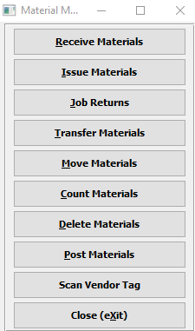

#### Receive Materials

Click the ***“Receive Materials”*** button to open the *Receive Materials Sharp Shooter* screen.

#### Issue Materials

Click the ***“Issue Materials”*** button to open the *Issue Materials Sharp Shooter* screen.

Bar Coded Load Tags may be scanned as issues records by pressing the ***“Issue Materials”*** button. Each tag scanned will create a raw materials issues line and the job number will transfer from the item’s bin location. For stock sheets and rolls, the job number must be manually entered or scanned from the job ticket. Purchase orders for specific jobs may automatically create the materials issues when the raw material receipt is created by creating bar coded load tags.

#### Job Returns

Click the ***“Job Returns”*** button to open the *Job Returns Sharp Shooter* screen.

#### Transfer Materials

Click the ***“Transfer Materials”*** button to open the *Transfer Materials Sharp Shooter* screen.

Raw materials transfers may be created directly to this file by scanning the bar-coded tag number by utilizing the Scan Issues Button. Alternatively, transfers may be manually added to this file by searching for the item and tag numbers. Once transfers for each tag number are created, the list of transfer records is displayed for updating, deletion and posting.

#### Move Materials

Click the ***“Move Materials”*** button to open the *Move Materials Sharp Shooter* screen.

#### Count Materials

Click the ***“Count Materials”*** button to open the *Count Materials Sharp Shooter* screen.

Raw materials physical counts may be transferred to this file from the Top Gun batch data collection scanning device by pressing the “***IMPORT Physical Count”*** Button or physical counts may be scanned directly from the plant floor by pressing the “***SCAN PHYSICAL COUNTS”*** Button. Lastly, physical counts may be manually added to this file by searching for the item and tag number, then entering the correct quantity. Once physical counts for each tag number have been imported or created, a list of counted records is shown for further updating, deletion and posting.

#### Delete Materials

Click the ***“Delete Materials”*** button to open the *Delete Materials Sharp Shooter* screen.

#### Post Materials

Click the ***“Post Materials”*** button to open the *Post Materials Sharp Shooter* screen.

The ***“Post”*** button on the main menu provides the ability to post warehouse transactions in a batch to a particular date. A job number range may be added to post a few select numbers of jobs. Likewise, transactions types may be selected to post any number of transactions such as receipts, issues, transfers, adjustment and Physical counts.

#### Scan Vendor Tag

Click the ***“Scan Vendor Tag”*** button to open the *Scan Vendor Tag Sharp Shooter* screen.

#### CLOSE

Click the ***“Close”*** button to exit the Raw Materials Sharp Shooter Main Menu.

## Receive Materials

### Overview

The “***PO Load”*** Tags button is pressed to create and print bar coded load tags. Each tag printed will simultaneously create raw materials receipts in the Enter/Edit Receipts file. In addition, receipts may be added directly from this file without using a scanning device.

When tags are created automatically the list of receipts are shown in this file for updating, deletion and posting. Receipts may be posted one at a time or in a batch via the “***POST”*** button. The list of receipts may be sorted by receipt date, purchase order number, item number and warehouse by clicking the appropriate circle at the bottom of the screen. To search alphabetically, click the appropriate sort option, enter in a continuous string of characters in the Auto Find box, then press “***Enter”***.

### Browse Receipts

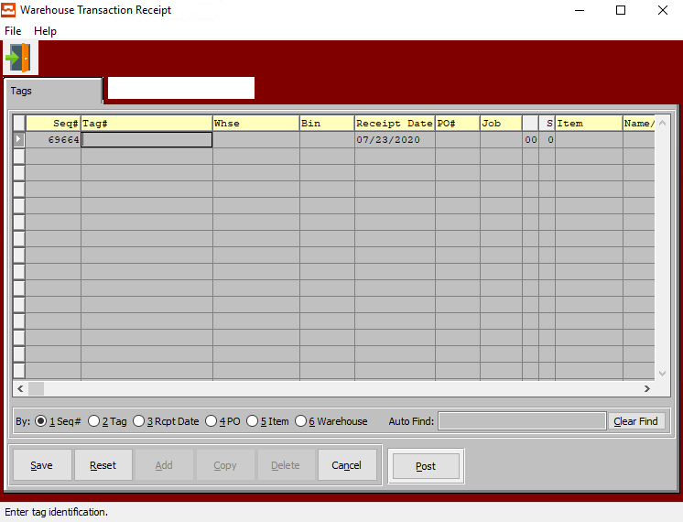

#### ADD

To manually add material receipts, press the “***Add”*** button at the bottom of the screen. Select any item by pressing “***F1”*** on the item code, then enter the remaining data and press the “***Enter”*** key or click the “***Save”*** button to save the transaction. The “***F1”*** key may be used to find an appropriate purchase order number, job number, warehouse, and bin location or unit of measure.

#### UPDATE

To update a material receipt, simply double click the item or press the “***Update”*** button at the bottom of the screen. Press the “***Enter”*** key or click the “***Save”*** button to save the transaction. The “***F1”*** key may be used to find an appropriate purchase order number, job number, warehouse, and bin location or unit of measure.

#### COPY

To copy a material receipt, highlight the item with a single click, then press the “***Copy”*** button at the bottom of the screen. Press the “***Enter”*** key or click the “***Save”*** button to save the transaction. The “***F1”*** key may be used to find an appropriate purchase order number, job number, warehouse, and bin location or unit of measure.

#### DELETE

To delete a material receipt, highlight the item with a single click, then press the “***Delete”*** button at the bottom of the screen. Press the “***Enter”*** key or click the “***Save”*** button to save the transaction. The “***F1”*** key may be used to find an appropriate purchase order number, job number, warehouse, and bin location or unit of measure.

#### POST

To Post a material receipt, highlight each item with a single click, then press the “***POST”*** button at the bottom of the screen. Alternatively, the “***POST”*** button on the main menu may be used to post the entire batch of receipts, issues, transfers, adjustments and physical counts.

### Add/Update Transaction Receipt

#### Sequence #

The Sequence Number is automatically given by the system. It is not modifiable by the user.

#### Tag #

When the Tag Number is scanned, this transfers to the PO#, PO Line# and Qty Fields. The Unit of Measure imports from the raw materials consumption unit of measure.

The RM Bar Code Tag format will be 999999 999 99999 99999 without any spaces.

* The first 6 digits represent the ASI PO#.
* The next 3 digits represent the ASI PO Line#.
* The last 5 digits represent the quantity on the roll or pallet.
* The last 5 digits represent the unique tag number.

A Warning Message should appear if the Tag Number already exists. This must be a unique number, otherwise the issue program will not know this tag number to select. The system now allows the user to enter the PO#, Line #, Qty, and then it duplicates the vendor tag #.

Alternatively, press the ***“F1”*** key to choose a valid Number from a list of available Tag Numbers.

#### Warehouse

This is the primary warehouse location for this item. The bin file will provide inventory control by warehouse, bin location and tag number. Enter the Primary Warehouse (loc). Alternatively, the user may press the ***“F1”*** key to select a warehouse from a list of available warehouses.

This list can be sorted by Location or Description. Alternatively, the user may search for any warehouse that they wish to use in order to narrow down their selection.

#### Bin

The bin location shows the location within the warehouse such as the aisle, bin location or floor location. Alternatively, the user may press the ***“F1”*** key to select the warehouse bin location information.

This list can be sorted by Warehouse or Bin. Alternatively, the user may search for any bin that they wish to use in order to narrow down their selection.

#### Receipt Date

Enter the date that the item was received, defaults to system date. This field automatically defaults to today’s date, but may be modified by the user.

#### PO #

Enter a valid purchase order number. Alternatively, press the ***“F1”*** key to choose a number from a list of valid purchase orders.

#### Job #

The job number defaults to the estimate number, but may be modified. The Job Factory Ticket will print by job number. Repeat jobs for an item will add a suffix to the original job number.

For example, a repeat job number could be Job number 88888-01 where 88888 is the original job and the 01 is the first repeat for that item.

All costs including, standard (estimated) labor, material and overhead, work in process, actual costs and variances are maintained by job number.

#### Job #: 00

Repeat jobs for an item will add a suffix to the original job number.

#### S

Enter the sheet form number which the material cost will be applied.

#### Item #

Enter the RM item number or you may use the ***“F1”*** look-up. A partial description may be typed into any field or data may be entered into multiple fields followed by pressing the ***“Go”*** button to sort the fields by the criteria that was entered.

#### Name/Description

This description name transfers from the estimate for custom boxes, however it must be entered for stock boxes. This line transfers to the job ticket, purchase order, and numerous other reports. The system also uses the Item Name for alpha-Alphanumeric searches. This field will automatically populate once the user has selected or entered the item number, and cannot be modified further.

#### Qty

This is the current quantity of this item. It will automatically transfer from the Item file as soon as the user enters or chooses a valid Tag number.

#### UOM (Qty)

The sell price unit of measure defaults to M for per thousand, however this may be modified. Each unit of measure will yield a different total selling price.

Valid Units of Measure are:

|  |  |
| --- | --- |
| C | Per Hundred |
| CS | Per Case |
| EA | Per Each |
| L | Per Lot |
| M | Per Thousand |

#### Cost

Enter the cost of the item. Three methods for determining the cost of an item exist; Standard Cost, Last Cost, and Average Cost. The company enters the costing method, that they want to use in the *F/G* Control file.

#### UOM (Cost)

The sell price unit of measure defaults to M for per thousand, however this may be modified. Each unit of measure will yield a different total selling price.

Valid Units of Measure are:

|  |  |
| --- | --- |
| C | Per Hundred |
| CS | Per Case |
| EA | Per Each |
| L | Per Lot |
| M | Per Thousand |

#### Ext. Amount

The cost for this Unit of Measure defaults from Raw Material, but may be modified by the user.

#### Width

Enter the board or paper width dimension for actual raw material. This field will transfer to the estimate automatically when an actual stocked board is used on an estimate. This field is not used for non-stocked board (item code=E) because the system will calculate the optimum sheet size based on the style formulas. In addition, if valid roll widths are defined on screen 2, then the system will find the closest roll width equal to or greater than the calculated sheet width.

#### Length

Enter the board or paper length dimension for actual raw material. This field will transfer to the estimate automatically when an actual stocked board is used on an estimate. This field should not be defined for non-stocked board (item code=E) because the system will calculate the optimum sheet length based on the style formulas.

#### User ID

The username of the original user that created this receipt in the system.

## Issue Materials

### Overview

Bar Coded Load Tags may be scanned as issues records by pressing the ***“Scan Issues”*** button. Each tag scanned will create a raw materials issues line and the job number will transfer from the item’s bin location. For stock sheets and rolls, the job number must be manually entered or scanned from the job ticket. Purchase orders for specific jobs may automatically create the materials issues when the raw material receipt is created by creating bar coded load tags.

To simultaneously issue tags upon receipts, the system administration auto issue flag is used. For more accurate and timelier inventory control, pallet and roll tag issues should be manually added directly to the Advantzware issues file by scanning the bar-coded tag number via the ***“Scan Issues”*** Button. Lastly, issues may be manually added to this file by searching for the item and tag numbers. Once the issues for each tag number are created, the list of issues are shown in this file for updating, deletion and posting. Issues may be posted one at a time or in a batch via the “***POST”*** button.

The list of issues may be sorted by receipt date, purchase order number, item number and warehouse by clicking the appropriate circle at the bottom of the screen. To search alphabetically, click the appropriate sort option, enter in a continuous string of characters in the Auto Find box, then press “***Enter”***.

### Browse Issues

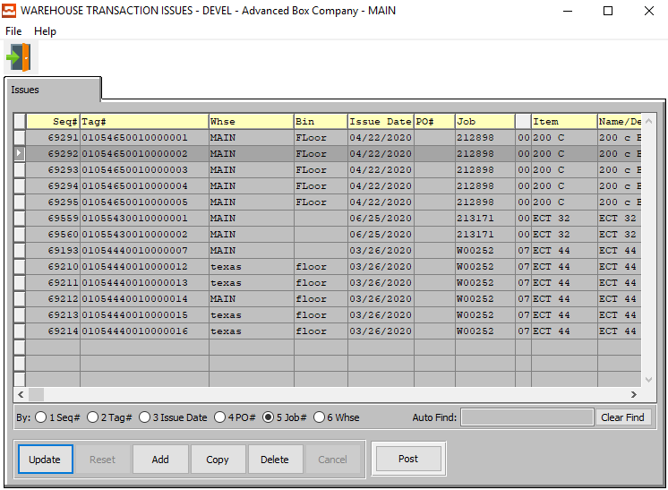

#### UPDATE

To update a material issue, simply double click the item or press the “***Update”*** button at the bottom of the screen. Press the “***Enter”*** key or click the “***Save”*** button to save the transaction. The “***F1”*** key may be used to find an appropriate purchase order number, job number, warehouse, and bin location or unit of measure.

#### ADD

To manually add material issues, press the “***Add”*** button at the bottom of the screen. Select any item by pressing “***F1”*** on the item code, then enter the remaining data and press the “***Enter”*** key or click the “***Save”*** button to save the transaction. The “***F1”*** key may be used to find an appropriate purchase order number, job number, warehouse, and bin location or unit of measure.

#### COPY

To copy a material issue, highlight the item with a single click, then press the “***Copy”*** button at the bottom of the screen. Press the “***Enter”*** key or click the “***Save”*** button to save the transaction. The “***F1”*** key may be used to find an appropriate purchase order number, job number, warehouse, and bin location or unit of measure.

#### DELETE

To delete a material issue, highlight the item with a single click, then press the “***Delete”*** button at the bottom of the screen. Press the “***Enter”*** key or click the “***Save”*** button to save the transaction. The “***F1”*** key may be used to find an appropriate purchase order number, job number, warehouse, and bin location or unit of measure.

#### POST

To Post a material issue, highlight each item with a single click, then press the “***POST”*** button at the bottom of the screen. Alternatively, the “***POST”*** button on the main menu may be used to post the entire batch of receipts, issues, transfers, adjustments and physical counts.

### Add/Update Issue

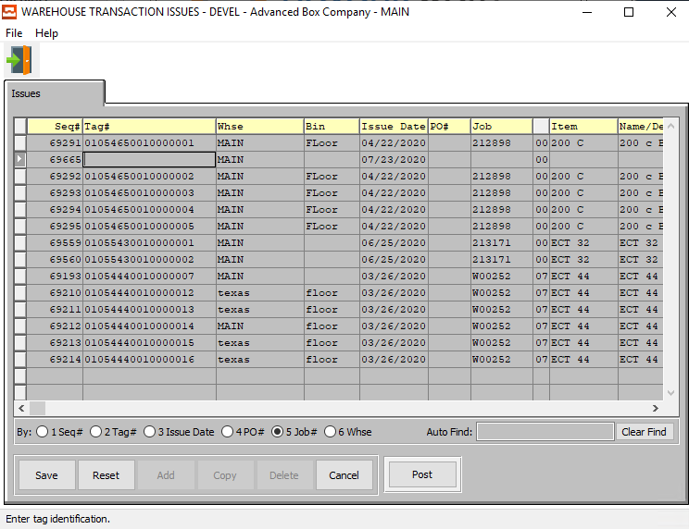

#### SAVE

Click the ***“Save”*** button to save all changes to the current Issue.

#### RESET

Click the ***“Reset”*** button to reset all fields to their original state.

#### CANCEL

Click the ***“Cancel”*** button to cancel all changes to the Issue without saving.

#### POST

To Post a material issue, highlight each item with a single click, then press the “***POST”*** button at the bottom of the screen. Alternatively, the “***POST”*** button on the main menu may be used to post the entire batch of receipts, issues, transfers, adjustments and physical counts.

### Add/Update Issue Field Definitions

#### Sequence #

The Sequence Number is automatically given by the system. It is not modifiable by the user.

#### Tag #

When the Tag Number is scanned, this transfers to the PO#, PO Line# and Qty Fields. The Unit of Measure imports from the raw materials consumption unit of measure.

The RM Bar Code Tag format will be 999999 999 99999 99999 without any spaces.

* The first 6 digits represent the ASI PO#.
* The next 3 digits represent the ASI PO Line#.
* The last 5 digits represent the quantity on the roll or pallet.
* The last 5 digits represent the unique tag number.

A Warning Message should appear if the Tag Number already exists. This must be a unique number, otherwise the issue program will not know this tag number to select. The system now allows the user to enter the PO#, Line #, Qty, and then it duplicates the vendor tag #.

Alternatively, press the ***“F1”*** key to choose a valid Number from a list of available Tag Numbers.

#### Warehouse

This is the primary warehouse location for this item. The bin file will provide inventory control by warehouse, bin location and tag number. Enter the Primary Warehouse (loc). Alternatively, the user may press the ***“F1”*** key to select a warehouse from a list of available warehouses.

This list can be sorted by Location or Description. Alternatively, the user may search for any warehouse that they wish to use in order to narrow down their selection.

#### Bin

The bin location shows the location within the warehouse such as the aisle, bin location or floor location. Alternatively, the user may press the ***“F1”*** key to select the warehouse bin location information.

This list can be sorted by Warehouse or Bin. Alternatively, the user may search for any bin that they wish to use in order to narrow down their selection.

#### Issue Date

Enter the date that the item was issued, defaults to system date. This field automatically defaults to today’s date, but may be modified by the user.

#### PO #

Enter a valid purchase order number. Alternatively, press the ***“F1”*** key to choose a number from a list of valid purchase orders.

#### Job #

The job number defaults to the estimate number, but may be modified. The Job Factory Ticket will print by job number. Repeat jobs for an item will add a suffix to the original job number.

For example, a repeat job number could be Job number 88888-01 where 88888 is the original job and the 01 is the first repeat for that item.

All costs including, standard (estimated) labor, material and overhead, work in process, actual costs and variances are maintained by job number.

#### Job #: 00

Repeat jobs for an item will add a suffix to the original job number.

#### Item Number

Enter the RM item number or you may use the ***“F1”*** look-up. A partial description may be typed into any field or data may be entered into multiple fields followed by pressing the ***“Go”*** button to sort the fields by the criteria that was entered.

#### Item Name/Description

This description name transfers from the estimate for custom boxes, however it must be entered for stock boxes. This line transfers to the job ticket, purchase order, and numerous other reports. The system also uses the Item Name for alpha-Alphanumeric searches. This field will automatically populate once the user has selected or entered the item number, and cannot be modified further.

#### S

Enter the sheet form number which the material cost will be applied.

#### B

Enter the blank form number which the material cost will be applied.

#### Qty

This is the current quantity of this item. It will automatically transfer from the Item file as soon as the user enters or chooses a valid Tag number.

#### UOM (Qty)

The sell price unit of measure defaults to M for per thousand, however this may be modified. Each unit of measure will yield a different total selling price.

Valid Units of Measure are:

|  |  |
| --- | --- |
| C | Per Hundred |
| CS | Per Case |
| EA | Per Each |
| L | Per Lot |
| M | Per Thousand |

#### Cost

Enter the cost of the item. Three methods for determining the cost of an item exist; Standard Cost, Last Cost, and Average Cost. The company enters the costing method, that they want to use in the *F/G* Control file.

#### UOM (Cost)

The sell price unit of measure defaults to M for per thousand, however this may be modified. Each unit of measure will yield a different total selling price.

Valid Units of Measure are:

|  |  |
| --- | --- |
| C | Per Hundred |
| CS | Per Case |
| EA | Per Each |
| L | Per Lot |
| M | Per Thousand |

#### Extended Amount

The cost for this Unit of Measure defaults from Raw Material, but may be modified by the user.

#### Width

Enter the board or paper width dimension for actual raw material. This field will transfer to the estimate automatically when an actual stocked board is used on an estimate. This field is not used for non-stocked board (item code=E) because the system will calculate the optimum sheet size based on the style formulas. In addition, if valid roll widths are defined on screen 2, then the system will find the closest roll width equal to or greater than the calculated sheet width.

#### Length

Enter the board or paper length dimension for actual raw material. This field will transfer to the estimate automatically when an actual stocked board is used on an estimate. This field should not be defined for non-stocked board (item code=E) because the system will calculate the optimum sheet length based on the style formulas.

#### User ID

The username of the original user that created this receipt in the system.

## Job Returns

### Browse Returns

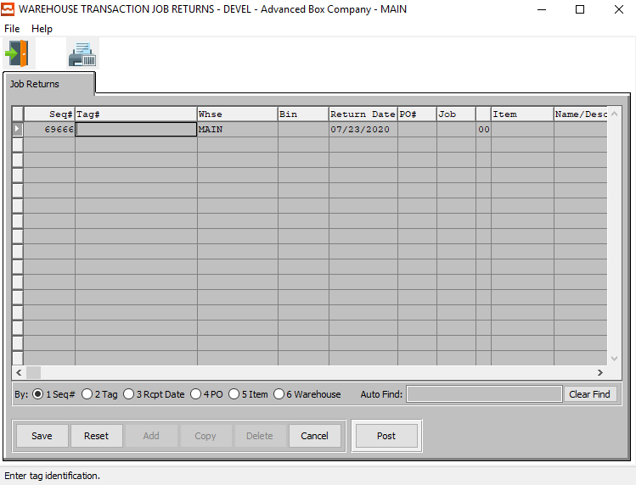

#### ADD

Click the ***“Add”*** button at the bottom of the screen to add a new Job Return.

#### POST

To Post a material job return, highlight each item with a single click, then press the “***POST”*** button at the bottom of the screen. Alternatively, the “***POST”*** button on the main menu may be used to post the entire batch of receipts, issues, transfers, adjustments and physical counts.

### Add Return

#### SAVE

Click the ***“Save”*** button to save all changes to the current Job Return.

#### RESET

Click the ***“Reset”*** button to reset all fields to their original state.

#### CANCEL

Click the ***“Cancel”*** button to cancel all changes to the Job Return without saving.

#### POST

To Post a material job return, highlight each item with a single click, then press the “***POST”*** button at the bottom of the screen. Alternatively, the “***POST”*** button on the main menu may be used to post the entire batch of receipts, issues, transfers, adjustments and physical counts.

### Add Return Field Definitions

#### Sequence #

The Sequence Number is automatically given by the system. It is not modifiable by the user.

#### Tag #

When the Tag Number is scanned, this transfers to the PO#, PO Line# and Qty Fields. The Unit of Measure imports from the raw materials consumption unit of measure.

The RM Bar Code Tag format will be 999999 999 99999 99999 without any spaces.

* The first 6 digits represent the ASI PO#.
* The next 3 digits represent the ASI PO Line#.
* The last 5 digits represent the quantity on the roll or pallet.
* The last 5 digits represent the unique tag number.

A Warning Message should appear if the Tag Number already exists. This must be a unique number, otherwise the issue program will not know this tag number to select. The system now allows the user to enter the PO#, Line #, Qty, and then it duplicates the vendor tag #.

Alternatively, press the ***“F1”*** key to choose a valid Number from a list of available Tag Numbers.

#### Warehouse

This is the primary warehouse location for this item. The bin file will provide inventory control by warehouse, bin location and tag number. Enter the Primary Warehouse (loc). Alternatively, the user may press the ***“F1”*** key to select a warehouse from a list of available warehouses.

This list can be sorted by Location or Description. Alternatively, the user may search for any warehouse that they wish to use in order to narrow down their selection.

#### Bin

The bin location shows the location within the warehouse such as the aisle, bin location or floor location. Alternatively, the user may press the ***“F1”*** key to select the warehouse bin location information.

This list can be sorted by Warehouse or Bin. Alternatively, the user may search for any bin that they wish to use in order to narrow down their selection.

#### Return Date

Enter the date that the item was returned, defaults to system date. This field automatically defaults to today’s date, but may be modified by the user.

#### PO #

Enter a valid purchase order number. Alternatively, press the ***“F1”*** key to choose a number from a list of valid purchase orders.

#### Job #

The job number defaults to the estimate number, but may be modified. The Job Factory Ticket will print by job number. Repeat jobs for an item will add a suffix to the original job number.

For example, a repeat job number could be Job number 88888-01 where 88888 is the original job and the 01 is the first repeat for that item.

All costs including, standard (estimated) labor, material and overhead, work in process, actual costs and variances are maintained by job number.

#### Job #: 00

Repeat jobs for an item will add a suffix to the original job number.

#### Item Number

Enter the RM item number or you may use the ***“F1”*** look-up. A partial description may be typed into any field or data may be entered into multiple fields followed by pressing the ***“Go”*** button to sort the fields by the criteria that was entered.

#### Item Name/Description

This description name transfers from the estimate for custom boxes, however it must be entered for stock boxes. This line transfers to the job ticket, purchase order, and numerous other reports. The system also uses the Item Name for alpha-Alphanumeric searches. This field will automatically populate once the user has selected or entered the item number, and cannot be modified further.

#### S

Enter the sheet form number which the material cost will be applied.

#### B

Enter the blank form number which the material cost will be applied.

#### Qty

This is the current quantity of this item. It will automatically transfer from the Item file as soon as the user enters or chooses a valid Tag number.

#### UOM (Qty)

The sell price unit of measure defaults to M for per thousand, however this may be modified. Each unit of measure will yield a different total selling price.

Valid Units of Measure are:

|  |  |
| --- | --- |
| C | Per Hundred |
| CS | Per Case |
| EA | Per Each |
| L | Per Lot |
| M | Per Thousand |

#### Cost

Enter the cost of the item. Three methods for determining the cost of an item exist; Standard Cost, Last Cost, and Average Cost. The company enters the costing method, that they want to use in the *F/G* Control file.

#### UOM (Cost)

The sell price unit of measure defaults to M for per thousand, however this may be modified. Each unit of measure will yield a different total selling price.

Valid Units of Measure are:

|  |  |
| --- | --- |
| C | Per Hundred |
| CS | Per Case |
| EA | Per Each |
| L | Per Lot |
| M | Per Thousand |

#### Extended Amount

The cost for this Unit of Measure defaults from Raw Material, but may be modified by the user.

#### Width

Enter the board or paper width dimension for actual raw material. This field will transfer to the estimate automatically when an actual stocked board is used on an estimate. This field is not used for non-stocked board (item code=E) because the system will calculate the optimum sheet size based on the style formulas. In addition, if valid roll widths are defined on screen 2, then the system will find the closest roll width equal to or greater than the calculated sheet width.

#### Length

Enter the board or paper length dimension for actual raw material. This field will transfer to the estimate automatically when an actual stocked board is used on an estimate. This field should not be defined for non-stocked board (item code=E) because the system will calculate the optimum sheet length based on the style formulas.

#### User ID

The username of the original user that created this receipt in the system.

## Transfer Materials

### Overview

Raw materials transfers may be created directly to this file by scanning the bar-coded tag number by utilizing the “***Scan Issues”*** Button. Alternatively, transfers may be manually added to this file by searching for the item and tag numbers. Once transfers for each tag number are created, the list of transfer records is displayed for updating, deletion and posting.

Transfers may be posted one at a time or in a batch via the “***POST”*** button. The list of transfers may be sorted by receipt date, purchase order number, item number and warehouse by clicking the appropriate circle at the bottom of the screen. To search alphabetically for a transfer record, click the appropriate sort option, enter in a continuous string of characters in the Auto Find box, then press “***Enter”***.

### Browse Transfers

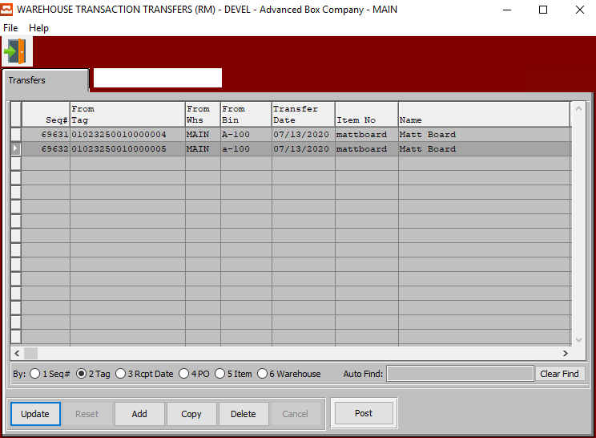

#### UPDATE

To update a material transfer, simply double click the item or press the “***Update”*** button at the bottom of the screen. Press the “***Enter”*** key or click the “***Save”*** button to save the transaction. The “***F1”*** key may be used to find an appropriate purchase order number, job number, warehouse, and bin location or unit of measure.

#### ADD

To manually add material transfers, press the “***Add”*** button at the bottom of the screen. Select any item by pressing “***F1”*** on the item code, then enter the remaining data and press the “***Enter”*** key or click the “***Save”*** button to save the transaction. The “***F1”*** key may be used to find an appropriate purchase order number, job number, warehouse, and bin location or unit of measure.

#### COPY

To copy a material transfer, highlight the item with a single click, then press the “***Copy”*** button at the bottom of the screen. Press the “***Enter”*** key or click the “***Save”*** button to save the transaction. The “***F1”*** key may be used to find an appropriate purchase order number, job number, warehouse, and bin location or unit of measure.

#### DELETE

To delete a material transfer, highlight the item with a single click, then press the “***Delete”*** button at the bottom of the screen. Press the “***Enter”*** key or click the “***Save”*** button to save the transaction. The “***F1”*** key may be used to find an appropriate purchase order number, job number, warehouse, and bin location or unit of measure.

#### POST

To Post a material transfer, highlight each item with a single click, then press the “***POST”*** button at the bottom of the screen. Alternatively, the “***POST”*** button on the main menu may be used to post the entire batch of receipts, issues, transfers, adjustments and physical counts.

### Add/Update Transfer

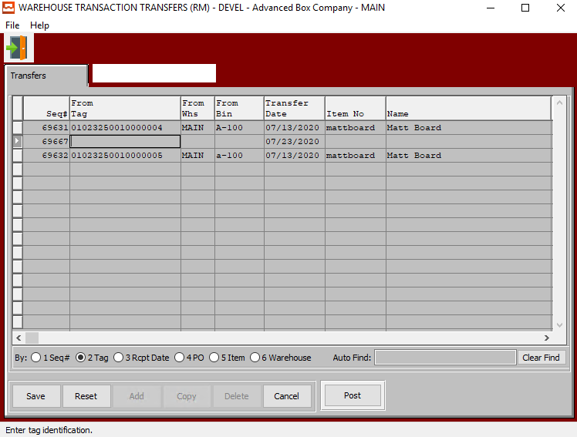

#### SAVE

Click the ***“Save”*** button to save all changes to the current Transfer.

#### RESET

Click the ***“Reset”*** button to reset all fields to their original state.

#### CANCEL

Click the ***“Cancel”*** button to cancel all changes to the Transfer without saving.

#### POST

To Post a material transfer, highlight each item with a single click, then press the “***POST”*** button at the bottom of the screen. Alternatively, the “***POST”*** button on the main menu may be used to post the entire batch of receipts, issues, transfers, adjustments and physical counts.

### Add/Update Transfer Field Definitions

#### Sequence #

The Sequence Number is automatically given by the system. It is not modifiable by the user.

#### From Tag / To Tag

Enter the beginning and ending Tag Number to transfer from and to, respectively.

#### From Warehouse / To Warehouse

Enter the beginning and ending Warehouse Location to transfer from and to, respectively.

#### From Bin / To Bin

Enter the beginning and ending Bin Number to transfer from and to, respectively.

#### Transfer Date

Enter the date that the item was transferred, defaults to system date. This field automatically defaults to today’s date, but may be modified by the user.

#### Item Number

Enter the RM item number or you may use the ***“F1”*** look-up. A partial description may be typed into any field or data may be entered into multiple fields followed by pressing the ***“Go”*** button to sort the fields by the criteria that was entered.

#### Item Name

This description name transfers from the estimate for custom boxes, however it must be entered for stock boxes. This line transfers to the job ticket, purchase order, and numerous other reports. The system also uses the Item Name for alpha-Alphanumeric searches. This field will automatically populate once the user has selected or entered the item number, and cannot be modified further.

#### Qty

Enter the quantity in this warehouse, bin, and tag for the item with this job number.

#### User ID

The username of the original user that created this receipt in the system.

## Move Materials

### Browse Material Receipts

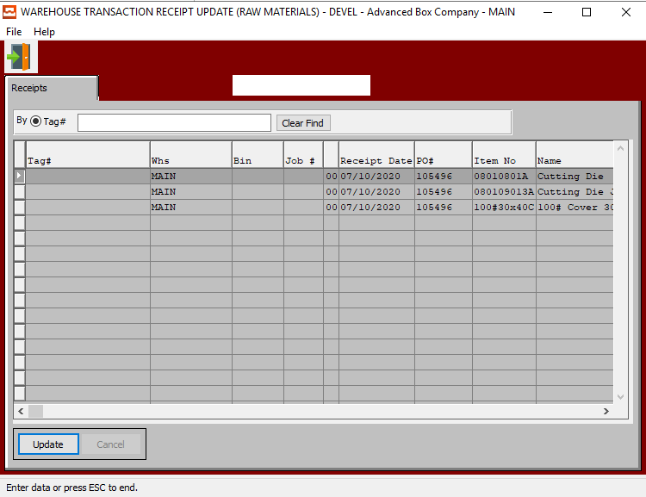

#### UPDATE

To change the currently selected Receipt, simply click the ***“Update***” button at the bottom of the screen.

### Update Material Receipts

#### SAVE

Click the ***“Save”*** button to save all changes to the current Receipt.

#### CANCEL

Click the ***“Cancel”*** button to cancel all changes to the Receipt without saving.

### Update Material Receipts Field Definitions

#### Tag #

When the Tag Number is scanned, this transfers to the PO#, PO Line# and Qty Fields. The Unit of Measure imports from the raw materials consumption unit of measure.

The RM Bar Code Tag format will be 999999 999 99999 99999 without any spaces.

* The first 6 digits represent the ASI PO#.
* The next 3 digits represent the ASI PO Line#.
* The last 5 digits represent the quantity on the roll or pallet.
* The last 5 digits represent the unique tag number.

A Warning Message should appear if the Tag Number already exists. This must be a unique number, otherwise the issue program will not know this tag number to select. The system now allows the user to enter the PO#, Line #, Qty, and then it duplicates the vendor tag #.

Alternatively, press the ***“F1”*** key to choose a valid Number from a list of available Tag Numbers.

#### Warehouse

This is the primary warehouse location for this item. The bin file will provide inventory control by warehouse, bin location and tag number. Enter the Primary Warehouse (loc). Alternatively, the user may press the ***“F1”*** key to select a warehouse from a list of available warehouses.

This list can be sorted by Location or Description. Alternatively, the user may search for any warehouse that they wish to use in order to narrow down their selection.

#### Bin

The bin location shows the location within the warehouse such as the aisle, bin location or floor location. Alternatively, the user may press the ***“F1”*** key to select the warehouse bin location information.

This list can be sorted by Warehouse or Bin. Alternatively, the user may search for any bin that they wish to use in order to narrow down their selection.

#### Job #

The job number defaults to the estimate number, but may be modified. The Job Factory Ticket will print by job number. Repeat jobs for an item will add a suffix to the original job number.

For example, a repeat job number could be Job number 88888-01 where 88888 is the original job and the 01 is the first repeat for that item.

All costs including, standard (estimated) labor, material and overhead, work in process, actual costs and variances are maintained by job number.

#### Job #: 00

Repeat jobs for an item will add a suffix to the original job number.

#### Receipt Date

Enter the date that the item was moved, defaults to system date. This field automatically defaults to today’s date, but may be modified by the user.

#### PO #

Enter a valid purchase order number. Alternatively, press the ***“F1”*** key to choose a number from a list of valid purchase orders.

#### Item Number

Enter the RM item number or you may use the ***“F1”*** look-up. A partial description may be typed into any field or data may be entered into multiple fields followed by pressing the ***“Go”*** button to sort the fields by the criteria that was entered.

#### Item Name

This description name transfers from the estimate for custom boxes, however it must be entered for stock boxes. This line transfers to the job ticket, purchase order, and numerous other reports. The system also uses the Item Name for alpha-Alphanumeric searches. This field will automatically populate once the user has selected or entered the item number, and cannot be modified further.

#### Cost/UOM

Enter the cost of the item. Three methods for determining the cost of an item exist; Standard Cost, Last Cost, and Average Cost. The company enters the costing method, that they want to use in the *F/G* Control file.

#### UOM

The sell price unit of measure defaults to M for per thousand, however this may be modified. Each unit of measure will yield a different total selling price.

Valid Units of Measure are:

|  |  |
| --- | --- |
| C | Per Hundred |
| CS | Per Case |
| EA | Per Each |
| L | Per Lot |
| M | Per Thousand |

#### Total Qty

Enter the quantity in this warehouse, bin, and tag for the item with this job number.

#### Purchase UOM

Valid Units of Measure are:

|  |  |
| --- | --- |
| C | Per Hundred |
| CS | Per Case |
| EA | Per Each |
| L | Per Lot |
| M | Per Thousand |

#### User ID

The username of the original user that created this receipt in the system.

## Count Materials

### Overview

Raw materials physical counts may be transferred to this file from the Top Gun batch data collection scanning device by pressing the “***IMPORT Physical Count”*** Button or physical counts may be scanned directly from the plant floor by pressing the “***SCAN PHYSICAL COUNTS”*** Button. Lastly, physical counts may be manually added to this file by searching for the item and tag number, then entering the correct quantity. Once physical counts for each tag number have been imported or created, a list of counted records is shown for further updating, deletion and posting.

Physical counts may be posted one at a time or in a batch via the “***POST”*** button. The list of items which were counted may be sorted by receipt date, purchase order number, item number and warehouse by clicking the appropriate circle at the bottom of the screen. To search alphabetically for an adjustment record, click the appropriate sort option, enter in a continuous string of characters in the Auto Find box, then press “***Enter”***.

### Browse Counts

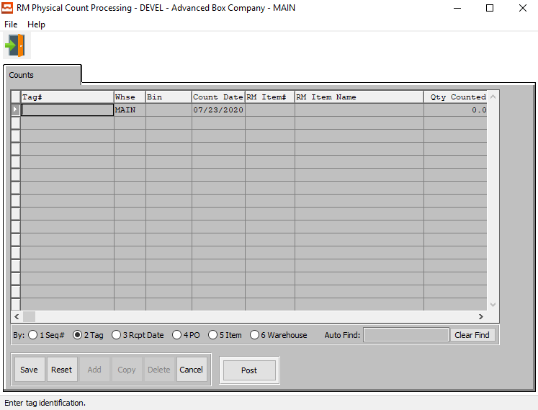

#### UPDATE

To update an items physical count, simply double click the item or press the “***Update”*** button at the bottom of the screen. Press the “***Enter”*** key or click the “***Save”*** button to save the transaction. The “***F1”*** key may be used to find an appropriate purchase order number, job number, warehouse, and bin location or unit of measure.

#### ADD

To manually add physical counts, press the “***Add”*** button at the bottom of the screen. Select any item by pressing “***F1”*** on the item code, then enter the remaining data and press the “***Enter”*** key or click the “***Save”*** button to save the transaction. The “***F1”*** key may be used to find an appropriate purchase order number, job number, warehouse, and bin location or unit of measure.

#### COPY

To copy a physical count record, highlight the item with a single click, then press the “***Copy”*** button at the bottom of the screen. Press the “***Enter”*** key or click the “***Save”*** button to save the transaction. The “***F1”*** key may be used to find an appropriate purchase order number, job number, warehouse, and bin location or unit of measure.

#### DELETE

To delete an items physical count, highlight the item with a single click, then press the “***Delete”*** button at the bottom of the screen. Press the “***Enter”*** key or click the “***Save”*** button to save the transaction. The “***F1”*** key may be used to find an appropriate purchase order number, job number, warehouse, and bin location or unit of measure.

#### POST

To post a physical count record or batch, highlight each item with a single click, and then press the “***POST”*** button at the bottom of the screen. Alternatively, the “***POST”*** button on the main menu may be used to post the entire batch of receipts, issues, transfers, adjustments and physical counts.

### Add Physical Count

#### SAVE

Click the ***“Save”*** button to save all changes to the current Physical Count.

#### RESET

Click the ***“Reset”*** button to reset all fields to their original state.

#### CANCEL

Click the ***“Cancel”*** button to cancel all changes to the Physical Count without saving.

#### POST

To post a physical count record or batch, highlight each item with a single click, and then press the “***POST”*** button at the bottom of the screen. Alternatively, the “***POST”*** button on the main menu may be used to post the entire batch of receipts, issues, transfers, adjustments and physical counts.

### Add Physical Count Field Definitions

#### Tag #

When the Tag Number is scanned, this transfers to the PO#, PO Line# and Qty Fields. The Unit of Measure imports from the raw materials consumption unit of measure.

The RM Bar Code Tag format will be 999999 999 99999 99999 without any spaces.

* The first 6 digits represent the ASI PO#.
* The next 3 digits represent the ASI PO Line#.
* The last 5 digits represent the quantity on the roll or pallet.
* The last 5 digits represent the unique tag number.

A Warning Message should appear if the Tag Number already exists. This must be a unique number, otherwise the issue program will not know this tag number to select. The system now allows the user to enter the PO#, Line #, Qty, and then it duplicates the vendor tag #.

Alternatively, press the ***“F1”*** key to choose a valid Number from a list of available Tag Numbers.

#### Warehouse

This is the primary warehouse location for this item. The bin file will provide inventory control by warehouse, bin location and tag number. Enter the Primary Warehouse (loc). Alternatively, the user may press the ***“F1”*** key to select a warehouse from a list of available warehouses.

This list can be sorted by Location or Description. Alternatively, the user may search for any warehouse that they wish to use in order to narrow down their selection.

#### Bin

The bin location shows the location within the warehouse such as the aisle, bin location or floor location. Alternatively, the user may press the ***“F1”*** key to select the warehouse bin location information.

This list can be sorted by Warehouse or Bin. Alternatively, the user may search for any bin that they wish to use in order to narrow down their selection.

#### Count Date

Enter the date that the item was counted, defaults to system date. This field automatically defaults to today’s date, but may be modified by the user.

#### RM Item #

Enter the RM item number or you may use the ***“F1”*** look-up. A partial description may be typed into any field or data may be entered into multiple fields followed by pressing the ***“Go”*** button to sort the fields by the criteria that was entered.

#### RM Item Name

This description name transfers from the estimate for custom boxes, however it must be entered for stock boxes. This line transfers to the job ticket, purchase order, and numerous other reports. The system also uses the Item Name for alpha-Alphanumeric searches. This field will automatically populate once the user has selected or entered the item number, and cannot be modified further.

#### Qty Counted

The user may enter the quantity of this item that was physically counted.

#### UOM

The sell price unit of measure defaults to M for per thousand, however this may be modified. Each unit of measure will yield a different total selling price.

Valid Units of Measure are:

|  |  |
| --- | --- |
| C | Per Hundred |
| CS | Per Case |
| EA | Per Each |
| L | Per Lot |
| M | Per Thousand |

#### User ID

The username of the original user that created this receipt in the system.

## Delete Materials

### Browse Deletions

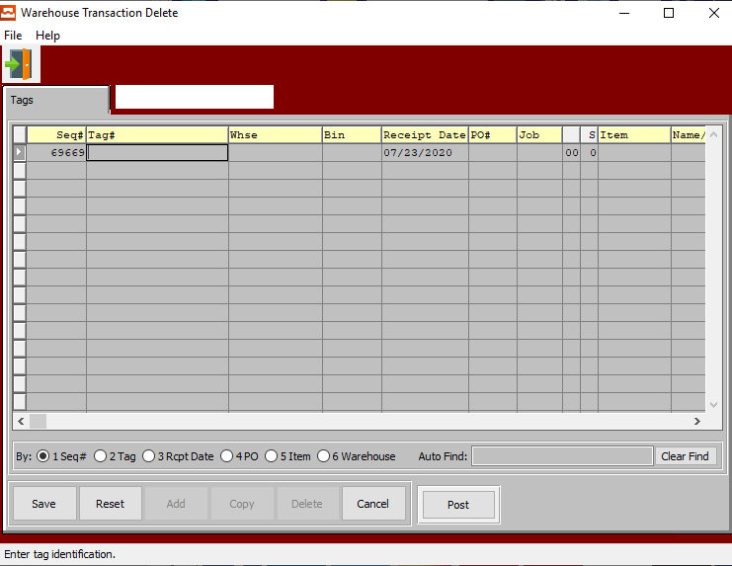

#### ADD

Click the ***“Add”*** button at the bottom of the screen to add a new Material Deletion.

#### POST

To post a physical count record or batch, highlight each item with a single click, and then press the “***POST”*** button at the bottom of the screen. Alternatively, the “***POST”*** button on the main menu may be used to post the entire batch of receipts, issues, transfers, adjustments and physical counts.

### Add Deletion

#### SAVE

Click the ***“Save”*** button to save all changes to the current Tag Deletion.

#### RESET

Click the ***“Reset”*** button to reset all fields to their original state.

#### CANCEL

Click the ***“Cancel”*** button to cancel all changes to the Tag Deletion without saving.

#### POST

To post a physical count record or batch, highlight each item with a single click, and then press the “***POST”*** button at the bottom of the screen. Alternatively, the “***POST”*** button on the main menu may be used to post the entire batch of receipts, issues, transfers, adjustments and physical counts.

### Add Deletion Field Definitions

#### Sequence #

The Sequence Number is automatically given by the system. It is not modifiable by the user.

#### Tag #

When the Tag Number is scanned, this transfers to the PO#, PO Line# and Qty Fields. The Unit of Measure imports from the raw materials consumption unit of measure.

The RM Bar Code Tag format will be 999999 999 99999 99999 without any spaces.

* The first 6 digits represent the ASI PO#.
* The next 3 digits represent the ASI PO Line#.
* The last 5 digits represent the quantity on the roll or pallet.
* The last 5 digits represent the unique tag number.

A Warning Message should appear if the Tag Number already exists. This must be a unique number, otherwise the issue program will not know this tag number to select. The system now allows the user to enter the PO#, Line #, Qty, and then it duplicates the vendor tag #.

Alternatively, press the ***“F1”*** key to choose a valid Number from a list of available Tag Numbers.

#### Warehouse

This is the primary warehouse location for this item. The bin file will provide inventory control by warehouse, bin location and tag number. Enter the Primary Warehouse (loc). Alternatively, the user may press the ***“F1”*** key to select a warehouse from a list of available warehouses.

This list can be sorted by Location or Description. Alternatively, the user may search for any warehouse that they wish to use in order to narrow down their selection.

#### Bin

The bin location shows the location within the warehouse such as the aisle, bin location or floor location. Alternatively, the user may press the ***“F1”*** key to select the warehouse bin location information.

This list can be sorted by Warehouse or Bin. Alternatively, the user may search for any bin that they wish to use in order to narrow down their selection.

#### Receipt Date

Enter the date that the item was deleted, defaults to system date. This field automatically defaults to today’s date, but may be modified by the user.

#### PO #

Enter a valid purchase order number. Alternatively, press the ***“F1”*** key to choose a number from a list of valid purchase orders.

#### Job #

The job number defaults to the estimate number, but may be modified. The Job Factory Ticket will print by job number. Repeat jobs for an item will add a suffix to the original job number.

For example, a repeat job number could be Job number 88888-01 where 88888 is the original job and the 01 is the first repeat for that item.

All costs including, standard (estimated) labor, material and overhead, work in process, actual costs and variances are maintained by job number.

#### Job #: 00

Repeat jobs for an item will add a suffix to the original job number.

#### S

Enter the sheet form number which the material cost will be applied.

#### Item Number

Enter the RM item number or you may use the ***“F1”*** look-up. A partial description may be typed into any field or data may be entered into multiple fields followed by pressing the ***“Go”*** button to sort the fields by the criteria that was entered.

#### Item Name/Description

This description name transfers from the estimate for custom boxes, however it must be entered for stock boxes. This line transfers to the job ticket, purchase order, and numerous other reports. The system also uses the Item Name for alpha-Alphanumeric searches. This field will automatically populate once the user has selected or entered the item number, and cannot be modified further.

#### Qty

Enter the quantity in this warehouse, bin, and tag for the item with this job number.

#### UOM (Qty)

The sell price unit of measure defaults to M for per thousand, however this may be modified. Each unit of measure will yield a different total selling price.

Valid Units of Measure are:

|  |  |
| --- | --- |
| C | Per Hundred |
| CS | Per Case |
| EA | Per Each |
| L | Per Lot |
| M | Per Thousand |

#### Cost

Enter the cost of the item. Three methods for determining the cost of an item exist; Standard Cost, Last Cost, and Average Cost. The company enters the costing method, that they want to use in the *F/G* Control file.

#### UOM (Cost)

The sell price unit of measure defaults to M for per thousand, however this may be modified. Each unit of measure will yield a different total selling price.

Valid Units of Measure are:

|  |  |
| --- | --- |
| C | Per Hundred |
| CS | Per Case |
| EA | Per Each |
| L | Per Lot |
| M | Per Thousand |

#### Extended Amount

The cost for this Unit of Measure defaults from Raw Material, but may be modified by the user.

#### Width

Enter the board or paper width dimension for actual raw material. This field will transfer to the estimate automatically when an actual stocked board is used on an estimate. This field is not used for non-stocked board (item code=E) because the system will calculate the optimum sheet size based on the style formulas. In addition, if valid roll widths are defined on screen 2, then the system will find the closest roll width equal to or greater than the calculated sheet width.

#### Length

Enter the board or paper length dimension for actual raw material. This field will transfer to the estimate automatically when an actual stocked board is used on an estimate. This field should not be defined for non-stocked board (item code=E) because the system will calculate the optimum sheet length based on the style formulas.

#### User ID

The username of the original user that created this receipt in the system.

## Post Materials

### Overview

The ***“Post”*** button on the main menu provides the ability to post warehouse transactions in a batch to a particular date. A job number range may be added to post a few select numbers of jobs. Likewise, transactions types may be selected to post any number of transactions such as receipts, issues, transfers, adjustment and Physical counts.

### Selection Parameters

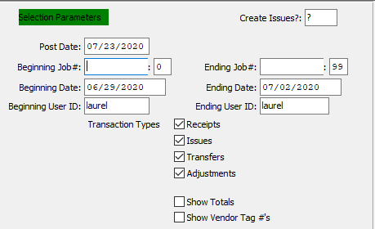

#### Create Issues?

To create issues for all files as they are posted, enter a ***“Y”*** in this field. If the user chooses to skip this step, enter an ***“N”*** in this field.

#### Post Date

Enter the post date of the Finished Items Goods file. This defaults as today’s date, but may be modified.

#### Beginning Job # / Ending Job #

Enter the beginning and ending Job Number to run the report for.

#### Beginning Job #: 00 / Ending Job #: 00

Enter the beginning and ending Subsequent Job Number to run the report for.

#### Beginning Date / Ending Date

Enter the beginning and ending Date to run the report for.

#### Beginning User ID / Ending User ID

Enter the beginning and ending User ID to run the report for.

#### Transaction Type: Receipts – Toggle Box

To post Receipt transactions, make sure that the Receipts toggle box is checked.

#### Transaction Type: Issues – Toggle Box

To post Issue transactions, make sure that the Issues toggle box is checked.

#### Transaction Type: Transfers – Toggle Box

To post Transfer transactions, make sure that the Transfers toggle box is checked.

#### Transaction Type: Adjustments – Toggle Box

To post Adjustment transactions, make sure that the Adjustments toggle box is checked.

#### Show Totals – Toggle Box

To show totals on the report, make sure that the Show Totals toggle box is checked.

#### Show Vendor Tag #’s – Toggle Box

To show Vendor Tag numbers on the report, make sure that the Show Vendor Tag #’s toggle box is checked.

### Output Destination

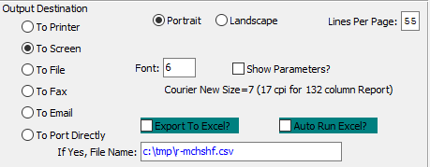

#### Destination Choice

To choose the destination where the document should be printed, please make sure that desired output destination choice bubble is toggled.

#### Layout Choice

To choose the preferred layout of Landscape vs. Portrait, please make sure the desired option choice bubbled is toggled.

#### Lines Per Page

Lines per page on the report when printing.

#### Font

Enter the font number to use with this report (Font 6 is default).

#### Show Parameters? – Toggle Box

To show parameters, make sure that the toggle box is ‘ticked’ with a checkmark.

#### Export to Excel? – Toggle Box

To export the printed file to an excel document, make sure that the Export to Excel toggle box is checked.

#### Auto Run Excel? – Toggle Box

To automatically open the new excel document, make sure that the Auto Run Excel toggle box is checked.

#### If Yes, File Name

If exporting the file to Excel, enter the desired file name.

## Scan Vendor Tag

### Overview

The Load Tag File for Raw Materials has a database field to house the bar code number provided by the board vendor which is represented as a bar coded tag number. Use the Sharp Shooter RM button called “***Scan Vendor Tags”***.

Click the “***Scan Vendor Tag”*** button to scan the vendor supplied Bar Code Number. If the Number has the proper format, all the information will transfer directly to the Screen including the Purchase Order Number, PO Line Number, Quantity Received and the Tag Number.

The Vendor RM Bar Code will equal PO#, PO Line#, Qty and Tag Number.

After Scanning the Vendor Tag, click the “***RECEIVE TAG”*** button and the data is loaded to the screen.  
Notice that both a new ASI tag number and vendor tag# are stored in the raw material tag file.  
Please note, the ***“N”-“K”-“1”*** SSPostVendorTags will eliminate this step as well as the step to post raw materials M-U-6. therefore, scanning a vendor tags will immediately result in on hand materials.

Scanning Vendor Tags works like the existing ***“M”-“U”-“8”*** program when creating pallet tags. This will create the load tag in the raw materials load tag file, which will download to RM tags depending on the item type. This will also download the PO#, Job#, item code, S/B code and same data loaded via the ***“M”-“U”-“8”*** load tag creation.

Each scanned vendor tag will create a new tag# in the Load Tag Raw Materials File with the quantity per tag then transfer the data to the SS Scan Vendor Tag program as a new RM receipt.

Please Note: The TEXT file need not be created, just the load tag file. When scanning the tag for ISSUES or COUNTS, the vendor tag must find the ASI Tag number.

### Browse Vendor Tags

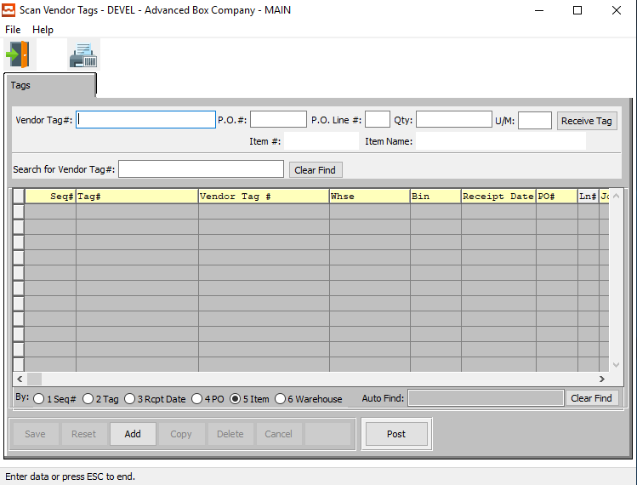

#### Vendor Tag #

When the Vendor Tag Number is scanned, this transfers to the PO#, PO Line# and Qty Fields. The Unit of Measure imports from the raw materials consumption unit of measure.

The RM Bar Code Tag format will be 999999 999 99999 99999 without any spaces.

* The first 6 digits represent the ASI PO#.
* The next 3 digits represent the ASI PO Line#.
* The last 5 digits represent the quantity on the roll or pallet.
* The last 5 digits represent the unique tag number.

A Warning Message should appear if the Vendor Tag Number already exists. This must be a unique number, otherwise the issue program will not know this tag number to select. The system now allows the user to enter the PO#, Line #, Qty, and then it duplicates the vendor tag #.

Alternatively, press the ***“F1”*** key to choose a valid Number from a list of available Tag Numbers.

#### P.O. #

Enter a valid purchase order number. Alternatively, press the ***“F1”*** key to choose a number from a list of valid purchase orders.

#### P.O. Line #

Enter the line reference number.

#### Qty

This is the current quantity of this item. It will automatically transfer from the Item file as soon as the user enters or chooses a valid Tag number.

#### U/M

The sell price unit of measure defaults to M for per thousand, however this may be modified. Each unit of measure will yield a different total selling price.

Valid Units of Measure are:

|  |  |
| --- | --- |
| C | Per Hundred |
| CS | Per Case |
| EA | Per Each |
| L | Per Lot |
| M | Per Thousand |

#### Item #

Enter the RM item number or you may use the ***“F1”*** look-up. A partial description may be typed into any field or data may be entered into multiple fields followed by pressing the ***“Go”*** button to sort the fields by the criteria that was entered.

#### Item Name

This description name transfers from the estimate for custom boxes, however it must be entered for stock boxes. This line transfers to the job ticket, purchase order, and numerous other reports. The system also uses the Item Name for alpha-Alphanumeric searches. This field will automatically populate once the user has selected or entered the item number, and cannot be modified further.

#### RECEIVE TAG

If the user is trying to scan a vendor tag that has not yet been received, they can press the ***“Receive Tag”*** button here after the tag has been entered or scanned. This will allow the user to quickly receive the new tag.

#### ADD

Click the ***“Add”*** button at the bottom of the screen to manually add a new vendor tag.

#### POST

To post a scanned vendor tag, highlight each item with a single click, and then press the “***POST”*** button at the bottom of the screen. Alternatively, the “***POST”*** button on the main menu may be used to post the entire batch of receipts, issues, transfers, adjustments and physical counts.

# **WIP Menu [BW]**

## Overview

### Main Menu

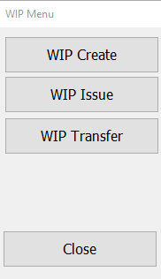

#### WIP Create

Click the ***“WIP Create”*** button to open the *Create Work in Process Sharp Shooter* screen.

#### WIP Issue

Click the ***“WIP Issue”*** button to open the *Issue Work in Process Sharp Shooter* screen.

#### WIP Transfer

Click the ***“WIP Transfer”*** button to open the *Transfer Work in Process Sharp Shooter* screen.

#### CLOSE

Click the ***“Close”*** button to exit the Work in Process Sharp Shooter Main Menu.

### Work in Process Icons

|  |  |  |
| --- | --- | --- |
|  | Keyboard | This icon will open the touch screen keyboard for the user. |
|  | Job Details | This icon will allow the user to view detailed information about the currently selected Work in Process. |
|  | Numeric Keypad | If this icon is highlighted in ***“Red”***, then the numeric keyboard is turned off. If it highlighted in ***“Green”***, then the numeric keyboard is turned on. |
|  | Print Tags | This icon will allow the user to print Load Tags for the selected Works in Process. |
|  | Next | This icon will move the user to the next Work in Process in the list. |
|  | Previous | This icon will move the user to the previous Work in Process in the list. |
|  | First | This icon will move the user to the first Work in Process in the list. |
|  | Last | This icon will move the user to the last Work in Process in the list. |
|  | Delete | This icon will delete the currently selected Work in Process from the list. |
|  | Exit | This icon will close the current screen. |

## WIP Create

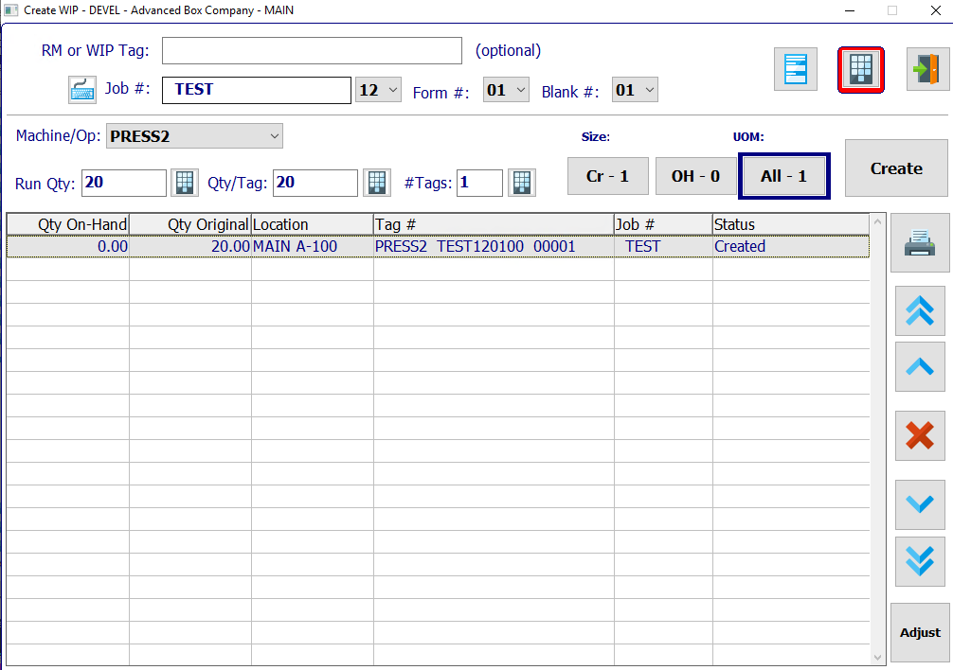

#### CREATE

Once the user has entered all their desired field definitions for the new Work in Process, they may click the ***“Create”*** button to create the WIP and add it to the browse list.

#### Cr – 1

Click the “Filter Created Tags” button to filter the browse list to only show tags whose current status is *Created*.

#### OH – 0

Click the “Filter On-Hand Tags” button to filter the browse list to only show tags whose current status is *On-Hand*.

#### All - 1

Click the “Filter All Tags” button to filter the browse list to show all available Work in Process tags.

#### ADJUST

Click the ***“Adjust”*** button to adjust the quantities or the currently selected Work in Process.

### Create Work in Process Field Definitions

#### RM or WIP Tag

Enter a Raw Material number or Work in Process tag number to search for.

#### Job #

The user may enter a Job number to search for in this field. Alternatively, press the ***“F1”*** key to choose a Job Number based on a list of available jobs.

#### Job #: 00

Once the user has entered or chosen a valid job number to search for, they may choose a valid subsequent job number for this job from the drop-down menu of available numbers.

#### Form #

Once the user has entered or chosen a valid job number to search for, they may choose a valid form number for this job from the drop-down menu of available numbers.

#### Blank #

Once the user has entered or chosen a valid job number to search for, they may choose a valid blank number for this job from the drop-down menu of available numbers.

#### Machine/Op

Once the user has entered or chosen a valid job number to search for, they may choose a valid machine or operator for this job from the drop-down menu of available numbers.

#### Run Qty

Enter the number of runs for this work in process.

#### Qty/Tag

Enter the quantity of items per tag.

#### # Tags

Enter the number of tags for this job.

### Adjust Work in Process

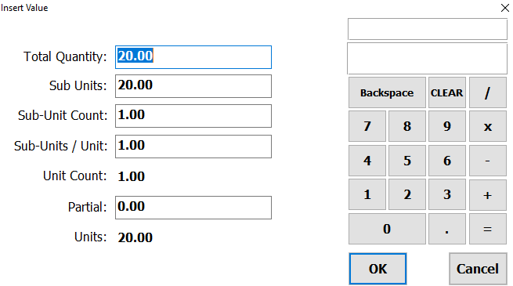

#### OK

Click the ***“Okay”*** button to save all changes to the currently selected Work in Process.

#### CANCEL

Click the ***“Cancel”*** button to exit the Adjustment screen without saving changes.

## WIP Issue

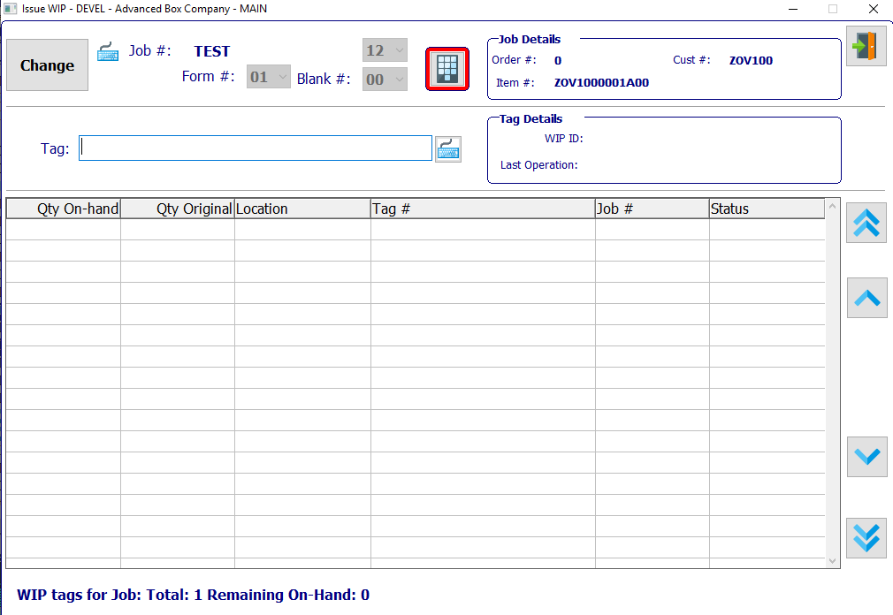

#### CHANGE

Click the ***“Change”*** button to change the currently selected Job Number.

### Issue Work in Process Field Definitions

#### Job #

The user may enter a Job number to search for in this field. Alternatively, press the ***“F1”*** key to choose a Job Number based on a list of available jobs.

#### Job #: 00

Once the user has entered or chosen a valid job number to search for, they may choose a valid subsequent job number for this job from the drop-down menu of available numbers.

#### Form #

Once the user has entered or chosen a valid job number to search for, they may choose a valid form number for this job from the drop-down menu of available numbers.

#### Blank #

Once the user has entered or chosen a valid job number to search for, they may choose a valid blank number for this job from the drop-down menu of available numbers.

#### Tag

Enter a tag number for this Work in Process.

## WIP Transfer

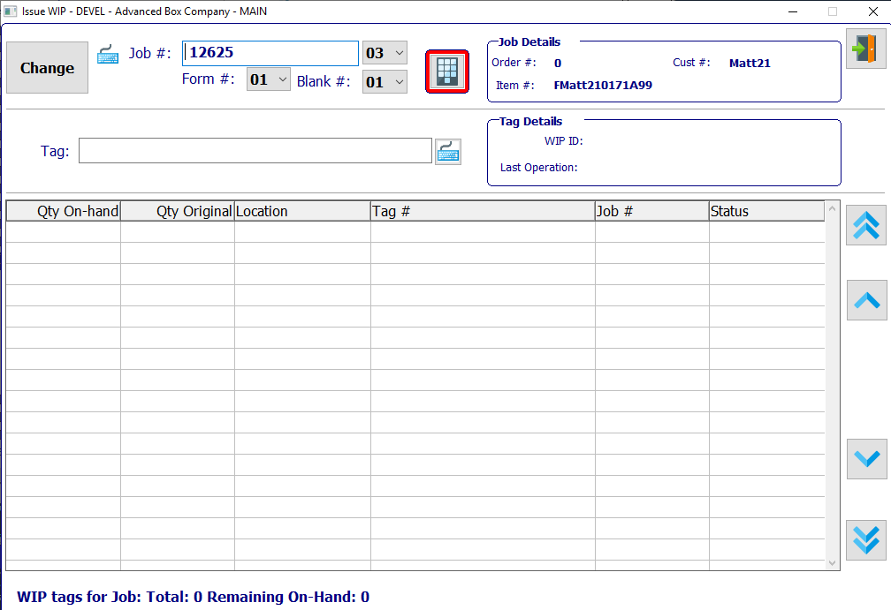

#### CHANGE

Click the ***“Change”*** button to change the currently selected Job Number.

### Transfer Work in Process Field Definitions

#### Job #

The user may enter a Job number to search for in this field. Alternatively, press the ***“F1”*** key to choose a Job Number based on a list of available jobs.

#### Job #: 00

Once the user has entered or chosen a valid job number to search for, they may choose a valid subsequent job number for this job from the drop-down menu of available numbers.

#### Form #

Once the user has entered or chosen a valid job number to search for, they may choose a valid form number for this job from the drop-down menu of available numbers.

#### Blank #

Once the user has entered or chosen a valid job number to search for, they may choose a valid blank number for this job from the drop-down menu of available numbers.

#### Tag

Enter a tag number for this Work in Process.

# **Finished Goods [BF]**

## Overview

Load tags may be created from purchasing, from jobs or directly from the Finished Goods file by pressing the appropriate button. When Finished Goods are received from purchasing, the receiving clerk will create load tags for the number of incoming pallets by pressing the load tag creation button. Each pallet tag created may simultaneously create Finished Goods receipts in the Advantzware Receipts file. Similarly, when Finished Goods are received from production, the receiving clerk will create load tags for the number of incoming pallets by pressing the ***“Load Tag Creation Tag”*** button.

Each tag created will simultaneously create Finished Goods receipts. Once the load tags are created, they will be attached to each pallet. The load tag will show the purchase order number, item number, job number, unit count and a bar code load tag number. For purchased finished goods, the bar code is created by combining the purchase order number, the line number, the unit number and the unit count for each pallet received. For finished goods produced from jobs, the bar code is created by combining the finished goods item code and a sequential number.

Alternatively, a vendor supplied load tag for purchased may be scanned, which will automatically create the warehouse receipt. Receipts for finished goods without bar coded tags may be added via the Enter/Modify Receipts button. The “***Post”*** button will update the inventory levels in the Advantzware database.

The “***Scan Bill of Lading”*** button is used to scan finished goods tag number onto the bill of lading, which will import the item number, tag number, job number and unit count to the Enter/Modify Bill of Lading file. The Advantzware system will be used to print the bill of lading and post the bill of lading.

The “***Scan Transfers”*** button is used to transfer Finished Good tags to another warehouse and bin location. Once the item’s tag number is scanned, the new warehouse and bin locations is scanned, then the transaction should be posted to update the inventory.

For physical counting, the warehouse clerk simply scans the pallet tag and verifies or adjusts the pallet count. Once the data has been collected, the information must be posted to the Advantzware database. The posting button logic will be used to update the inventory files.

### Main Menu

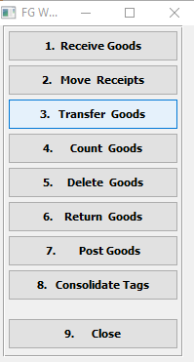

#### Receive Goods

Click the ***“Receive Goods”*** button to open the *Receive Goods Sharp Shooter* screen.

Load Tags created from purchase orders, jobs or from inventory button will create receipts transactions in the warehouse receipts file. Each load tag created will simultaneously create Finished Goods receipts in the Enter/Edit Receipts file. In addition, receipts may be added directly from this file without using a scanning device.

#### Move Receipts

Click the ***“Move Receipts”*** button to open the *Move Receipts Sharp Shooter* screen.

#### Transfer Goods

Click the ***“Transfer Goods”*** button to open the *Transfer Goods Sharp Shooter* screen.

Finished Goods transfers may be created directly to this file by scanning the bar-coded tag number by utilizing the Scan Issues Button. Alternatively, transfers may be manually added to this file by searching for the item and tag numbers. Once transfers for each tag number are created, the list of transfer records is displayed for updating, deletion and posting.

#### Count Goods

Click the ***“Count Goods”*** button to open the *Count Goods Sharp Shooter* screen.

Finished Goods physical counts may be transferred to this file from the Top Gun batch data collection scanning device by pressing the “***IMPORT Physical Count”*** Button or physical counts may be scanned directly from the plant floor by pressing the “***SCAN PHYSICAL COUNTS”*** Button. Lastly, physical counts may be manually added to this file by searching for the item and tag number, then entering the correct quantity.

#### Delete Goods

Click the ***“Delete Goods”*** button to open the *Delete Goods Sharp Shooter* screen.

The ***“Delete”*** button creates a negative receipt, which will offset the positive receipt, thereby making Quantity Produced = 0, and Quantity on hand = 0. The user can only scan tags that have a positive on-hand balance.

#### Return Goods

Click the ***“Return Goods”*** button to open the *Return Goods Sharp Shooter* screen.

#### Post Goods

Click the ***“Post Goods”*** button to open the *Post Goods Sharp Shooter* screen.

#### Consolidate Tags

Click the ***“Consolidate Tags”*** button to open the *Consolidate Tags Sharp Shooter* screen.

#### CLOSE

Click the ***“Close”*** button to exit the Finished Goods Sharp Shooter Main Menu.

## Receive Goods

### Overview

Load Tags created from purchase orders, jobs or from inventory button will create receipts transactions in the warehouse receipts file. Each load tag created will simultaneously create Finished Goods receipts in the Enter/Edit Receipts file. In addition, receipts may be added directly from this file without using a scanning device.

When tags are created automatically the list of receipts are shown in this file for updating, deletion and posting. Receipts may be posted one at a time or in a batch via the “***POST”*** button. The list of receipts may be sorted by receipt date, purchase order number, item number and warehouse by clicking the appropriate circle at the bottom of the screen. To search alphabetically, click the appropriate sort option, enter in a continuous string of characters in the Auto Find box, then press “***Enter”***.

### Receipts

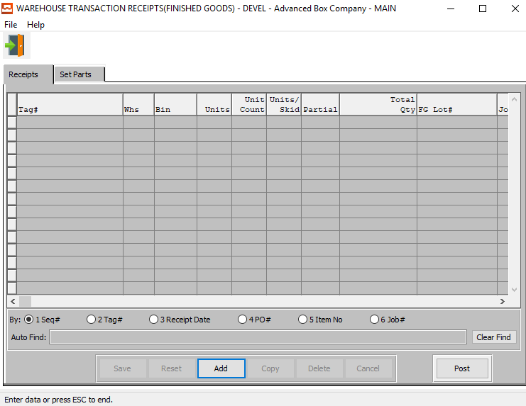

#### UPDATE

To update a Finished Goods receipt, simply double click the item or press the “***Update”*** button at the bottom of the screen. Press the “***Enter”*** key or click the “***Save”*** button to save the transaction. The “***F1”*** key may be used to find an appropriate purchase order number, job number, warehouse, and bin location or unit of measure.

#### ADD

To manually add finished goods receipts, press the “***Add”*** button at the bottom of the screen. Select any item by pressing “***F1”*** on the item code, then enter the remaining data and press the “***Enter”*** key or click the “***Save”*** button to save the transaction. The “***F1”*** key may be used to find an appropriate purchase order number, job number, warehouse, and bin location or unit of measure.

#### COPY

To copy a Finished Goods receipt, highlight the item with a single click, then press the “***Copy”*** button at the bottom of the screen. Press the “***Enter”*** key or click the “***Save”*** button to save the transaction. The “***F1”*** key may be used to find an appropriate purchase order number, job number, warehouse, and bin location or unit of measure.

#### DELETE

To delete a Finished Goods receipt, highlight the item with a single click, then press the “***Delete”*** button at the bottom of the screen. Press the “***Enter”*** key or click the “***Save”*** button to save the transaction. The “***F1”*** key may be used to find an appropriate purchase order number, job number, warehouse, and bin location or unit of measure.

#### POST

To Post a Finished Goods receipt, highlight each item with a single click, then press the “***POST”*** button at the bottom of the screen. Alternatively, the “***POST”*** button on the main menu may be used to post the entire batch of receipts, issues, transfers, adjustments and physical counts.

### Add Receipt

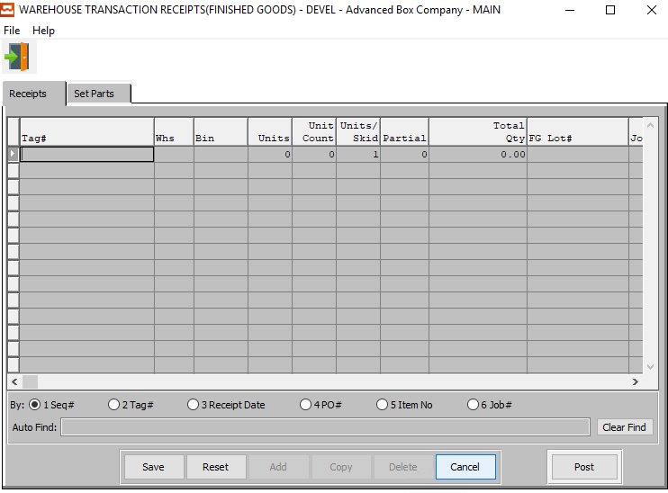

#### SAVE

Click the ***“Save”*** button to save all changes to the current Receipt.

#### RESET

Click the ***“Reset”*** button to reset all fields to their original state.

#### CANCEL

Click the ***“Cancel”*** button to cancel all changes to the Receipt without saving.

#### POST

To Post a Finished Goods receipt, highlight each item with a single click, then press the “***POST”*** button at the bottom of the screen. Alternatively, the “***POST”*** button on the main menu may be used to post the entire batch of receipts, issues, transfers, adjustments and physical counts.

### Add Receipt Field Definitions

#### Tag #

Enter a unique tag number for this Finished Good receipt.

A Warning Message should appear if the Tag Number already exists. This must be a unique number, otherwise the issue program will not know this tag number to select. The system now allows the user to enter the PO#, Line #, Qty, and then it duplicates the vendor tag #.

Alternatively, press the ***“F1”*** key to choose a valid Number from a list of available Tag Numbers.

#### Warehouse

This is the primary warehouse location for this item. The bin file will provide inventory control by warehouse, bin location and tag number. Enter the Primary Warehouse (loc). Alternatively, the user may press the ***“F1”*** key to select a warehouse from a list of available warehouses.

This list can be sorted by Location or Description. Alternatively, the user may search for any warehouse that they wish to use in order to narrow down their selection.

#### Bin

The bin location shows the location within the warehouse such as the aisle, bin location or floor location. Alternatively, the user may press the ***“F1”*** key to select the warehouse bin location information.

This list can be sorted by Warehouse or Bin. Alternatively, the user may search for any bin that they wish to use in order to narrow down their selection.

#### Units

Enter the number of units received of the item into this bin in this warehouse.

#### Units/Skid

Enter the number of units per skid.

#### Partial

Enter a partial quantity.

#### Total Qty

The Total Quantity is automatically calculated by the system using the Units, Unit Count, and Units/Skid fields. This field is not directly modifiable by the user, but it will update if the user changes the information in any of the aforementioned fields.

#### FG Lot #

Enter the lot number for this Finished Good

#### Job #

The job number defaults to the estimate number, but may be modified. The Job Factory Ticket will print by job number. Repeat jobs for an item will add a suffix to the original job number.

For example, a repeat job number could be Job number 88888-01 where 88888 is the original job and the 01 is the first repeat for that item.

All costs including, standard (estimated) labor, material and overhead, work in process, actual costs and variances are maintained by job number.

#### Job #: 00

Repeat jobs for an item will add a suffix to the original job number.

#### PO #

This field is for the Order Number of Purchased Finished Goods only. The number entered must be a valid PO# from the ASI Purchasing Module. The user may enter a PO Number, or press the ***“F1”*** key to select the PO # from a list of all available Purchase Orders.

#### Item #

Enter the Finished Good Item Number in this field. Alternatively, the Item Number field will automatically fill when the user selects their Tag Number.

The user can also press the ***“F1”*** key to search through all available Finished Goods items.

This list can be sorted by Item Number or Item Name. Alternatively, the user may search for any item that they wish to use in order to narrow down their selection.

Once an item is selected, this will automatically fill in several other fields with necessary information from the Item File.

#### Item Name

This description name transfers from the estimate for custom boxes, however it must be entered for stock boxes. This line transfers to the job ticket, purchase order, and numerous other reports. The system also uses the Item Name for alpha-Alphanumeric searches. This field will automatically populate once the user has selected or entered the item number, and cannot be modified further.

#### Cost/UOM

Enter the cost of the item. Three methods for determining the cost of an item exist; Standard Cost, Last Cost, and Average Cost. The company enters the costing method, that they want to use in the *F/G* Control file.

#### UOM

The sell price unit of measure defaults to M for per thousand, however this may be modified. Each unit of measure will yield a different total selling price.

Valid Units of Measure are:

|  |  |
| --- | --- |
| C | Per Hundred |
| CS | Per Case |
| EA | Per Each |
| L | Per Lot |
| M | Per Thousand |

#### Freight Cost

Enter the total freight amount for the Bill of Lading. If the weight per pallet or total Bill of Lading weight is entered in addition to the freight cost per hundred weight, the total freight cost is calculated.

#### Extended Cost

The cost for this Unit of Measure defaults from Raw Material, but may be modified by the user.

#### Sequence #

The Sequence Number is automatically given by the system. It is not modifiable by the user.

#### Receipt Date

Enter the date that the item was received, defaults to system date. This field automatically defaults to today’s date, but may be modified by the user.

### Set Parts

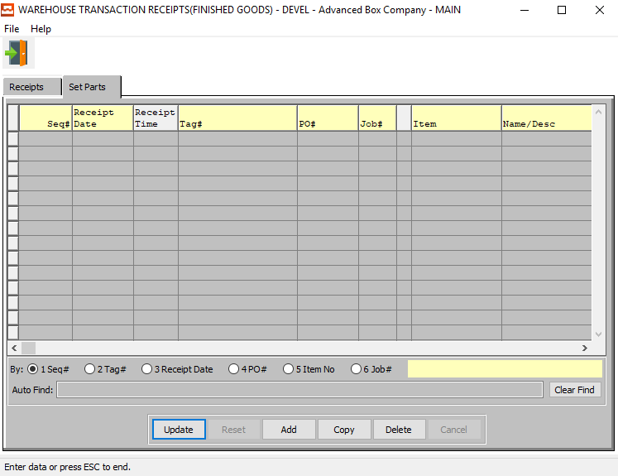

#### UPDATE

To change the currently selected Set Part, simply click the ***“Update***” button at the bottom of the screen.

#### ADD

Click the ***“Add”*** button at the bottom of the screen to add a new Set Part.

#### COPY

Click the ***“Copy”*** button to copy information from the currently selected Set Part.

#### DELETE

To delete the currently selected Set Part, simply press the ***"D"*** key. Alternatively, click the ***“Delete”*** button at the bottom of the screen.

### Add/Update Set Parts

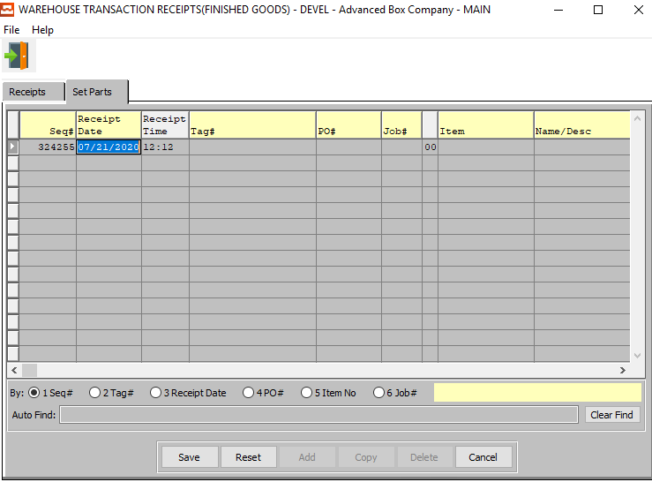

#### SAVE

Click the ***“Save”*** button to save all changes to the current Set Part.

#### RESET

Click the ***“Reset”*** button to reset all fields to their original state.

#### CANCEL

Click the ***“Cancel”*** button to cancel all changes to the Set Part without saving.

### Add/Update Set Parts Field Definitions

#### Sequence #

The Sequence Number is automatically given by the system. It is not modifiable by the user.

#### Receipt Date

Enter the date that the item was received, defaults to system date. This field automatically defaults to today’s date, but may be modified by the user.

#### Receipt Time

The time that the new receipt is made. This defaults to the system time, but can be modified by the user.

#### Tag #

Enter a unique tag number for this Finished Good receipt.

A Warning Message should appear if the Tag Number already exists. This must be a unique number, otherwise the issue program will not know this tag number to select. The system now allows the user to enter the PO#, Line #, Qty, and then it duplicates the vendor tag #.

Alternatively, press the ***“F1”*** key to choose a valid Number from a list of available Tag Numbers.

#### PO #

This field is for the Order Number of Purchased Finished Goods only. The number entered must be a valid PO# from the ASI Purchasing Module. The user may enter a PO Number, or press the ***“F1”*** key to select the PO # from a list of all available Purchase Orders.

This list can be sorted by PO Number, Vendor Item, or Item Number. Alternatively, the user may search for a PO #, Vendor Item, or Item # that they wish to use in order to narrow down their selection.

#### Job #

The job number defaults to the estimate number, but may be modified. The Job Factory Ticket will print by job number. Repeat jobs for an item will add a suffix to the original job number.

For example, a repeat job number could be Job number 88888-01 where 88888 is the original job and the 01 is the first repeat for that item.

All costs including, standard (estimated) labor, material and overhead, work in process, actual costs and variances are maintained by job number.

#### Job #: 00

Repeat jobs for an item will add a suffix to the original job number.

#### Item Number

Enter the Finished Good Item Number in this field. Alternatively, the Item Number field will automatically fill when the user selects their Tag Number.

The user can also press the ***“F1”*** key to search through all available Finished Goods items.

This list can be sorted by Item Number or Item Name. Alternatively, the user may search for any item that they wish to use in order to narrow down their selection.

#### Item Name / Description

This description name transfers from the estimate for custom boxes, however it must be entered for stock boxes. This line transfers to the job ticket, purchase order, and numerous other reports. The system also uses the Item Name for alpha-Alphanumeric searches. This field will automatically populate once the user has selected or entered the item number, and cannot be modified further.

#### Warehouse

This is the primary warehouse location for this item. The bin file will provide inventory control by warehouse, bin location and tag number. Enter the Primary Warehouse (loc). Alternatively, the user may press the ***“F1”*** key to select a warehouse from a list of available warehouses.

This list can be sorted by Location or Description. Alternatively, the user may search for any warehouse that they wish to use in order to narrow down their selection.

#### Bin

The bin location shows the location within the warehouse such as the aisle, bin location or floor location. Alternatively, the user may press the ***“F1”*** key to select the warehouse bin location information.

This list can be sorted by Warehouse or Bin. Alternatively, the user may search for any bin that they wish to use in order to narrow down their selection.

#### Units

Enter the number of units received of the item into this bin in this warehouse.

#### Units per Pallet

Enter the number of units per pallet.

#### Partial

Enter a partial quantity.

#### Cost/UOM

Enter the cost of the item. Three methods for determining the cost of an item exist; Standard Cost, Last Cost, and Average Cost. The company enters the costing method, that they want to use in the *F/G* Control file.

#### UOM

The sell price unit of measure defaults to M for per thousand, however this may be modified. Each unit of measure will yield a different total selling price.

Valid Units of Measure are:

|  |  |
| --- | --- |
| C | Per Hundred |
| CS | Per Case |
| EA | Per Each |
| L | Per Lot |
| M | Per Thousand |

#### Total Qty

The Total Quantity is automatically calculated by the system using the Units, Unit Count, and Units/Skid fields. This field is not directly modifiable by the user, but it will update if the user changes the information in any of the aforementioned fields.

#### Freight Cost

Enter the total freight amount for the Bill of Lading. If the weight per pallet or total Bill of Lading weight is entered in addition to the freight cost per hundred weight, the total freight cost is calculated.

#### Extended Cost

The cost for this Unit of Measure defaults from Raw Material, but may be modified by the user.

#### FG Lot #

Enter the lot number for this Finished Good

#### Created By

The username of the original user that created this receipt in the system.

#### Last Update

The username of the last user to have updated this receipt in the system.

#### Total Weight

The Total Weight is automatically calculated by the system using the Cost/UOM and UOM fields. This field is not directly modifiable by the user, but it will update if the user changes the information in either of the ‘Cost/UOM’ or ‘UOM’ fields.

## Move Receipts

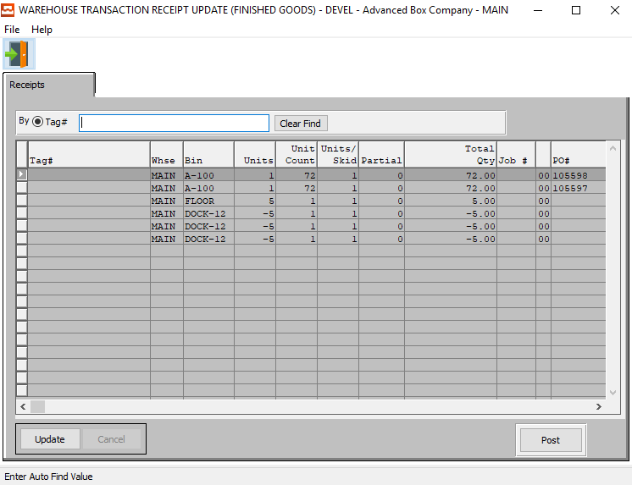

#### UPDATE

To change the currently selected Receipt, simply click the ***“Update***” button at the bottom of the screen.

#### POST

To post a receipt, highlight each item with a single click, and then press the “***POST”*** button at the bottom of the screen. Alternatively, the “***POST”*** button on the main menu may be used to post the entire batch of receipts, issues, transfers, adjustments and physical counts.

### Update Receipt

#### SAVE

Click the ***“Save”*** button to save all changes to the current Receipt.

#### CANCEL

Click the ***“Cancel”*** button to cancel all changes to the Receipt without saving.

#### POST

To post a receipt, highlight each item with a single click, and then press the “***POST”*** button at the bottom of the screen. Alternatively, the “***POST”*** button on the main menu may be used to post the entire batch of receipts, issues, transfers, adjustments and physical counts.

### Update Receipt Field Definitions

#### Warehouse

This is the primary warehouse location for this item. The bin file will provide inventory control by warehouse, bin location and tag number. Enter the Primary Warehouse (loc). Alternatively, the user may press the ***“F1”*** key to select a warehouse from a list of available warehouses.

This list can be sorted by Location or Description. Alternatively, the user may search for any warehouse that they wish to use in order to narrow down their selection.

#### Bin

The bin location shows the location within the warehouse such as the aisle, bin location or floor location. Alternatively, the user may press the ***“F1”*** key to select the warehouse bin location information.

This list can be sorted by Warehouse or Bin. Alternatively, the user may search for any bin that they wish to use in order to narrow down their selection.

#### Units

Enter the number of units received of the item into this bin in this warehouse.

#### Units/Skid

Enter the number of units per skid.

#### Partial

Enter a partial quantity.

#### Total Qty

The Total Quantity is automatically calculated by the system using the Units, Unit Count, and Units/Skid fields. This field is not directly modifiable by the user, but it will update if the user changes the information in any of the aforementioned fields.

#### Job #

The job number defaults to the estimate number, but may be modified. The Job Factory Ticket will print by job number. Repeat jobs for an item will add a suffix to the original job number.

For example, a repeat job number could be Job number 88888-01 where 88888 is the original job and the 01 is the first repeat for that item.

All costs including, standard (estimated) labor, material and overhead, work in process, actual costs and variances are maintained by job number.

#### Job #: 00

Repeat jobs for an item will add a suffix to the original job number.

#### PO #

This field is for the Order Number of Purchased Finished Goods only. The number entered must be a valid PO# from the ASI Purchasing Module. The user may enter a PO Number, or press the ***“F1”*** key to select the PO # from a list of all available Purchase Orders.

#### Item Number

Enter the Finished Good Item Number in this field. Alternatively, the Item Number field will automatically fill when the user selects their Tag Number. Alternatively, the user can also press the ***“F1”*** key to search through all available Finished Goods items.

Once an item is selected, this will automatically fill in several other fields with necessary information from the Item File.

#### Item Name

This description name transfers from the estimate for custom boxes, however it must be entered for stock boxes. This line transfers to the job ticket, purchase order, and numerous other reports. The system also uses the Item Name for alpha-Alphanumeric searches. This field will automatically populate once the user has selected or entered the item number, and cannot be modified further.

#### Cost/UOM

Enter the cost of the item. Three methods for determining the cost of an item exist; Standard Cost, Last Cost, and Average Cost. The company enters the costing method, that they want to use in the *F/G* Control file.

#### UOM

The sell price unit of measure defaults to M for per thousand, however this may be modified. Each unit of measure will yield a different total selling price. Valid Units of Measure are:

|  |  |
| --- | --- |
| C | Per Hundred |
| CS | Per Case |
| EA | Per Each |
| L | Per Lot |
| M | Per Thousand |

#### Extended Cost

The cost for this Unit of Measure defaults from Raw Material, but may be modified by the user.

#### FG Lot #

Enter the lot number for this Finished Good

#### User Created

The username of the original user that created this receipt in the system.

#### User Updated

The username of the last user to have updated this receipt in the system.

#### Receipt Date

Enter the date that the item was received, defaults to system date. This field automatically defaults to today’s date, but may be modified by the user.

#### Receipt Time

The time that the new receipt is made. This defaults to the system time, but can be modified by the user.

## Transfer Goods

### Overview

Finished Goods transfers may be created directly to this file by scanning the bar-coded tag number by utilizing the Scan Issues Button. Alternatively, transfers may be manually added to this file by searching for the item and tag numbers. Once transfers for each tag number are created, the list of transfer records is displayed for updating, deletion and posting.

Transfers may be posted one at a time or in a batch via the “***POST”*** button. The list of transfers may be sorted by receipt date, purchase order number, item number and warehouse by clicking the appropriate circle at the bottom of the screen. To search alphabetically for a transfer record, click the appropriate sort option, enter in a continuous string of characters in the Auto Find box, then press “***Enter”***.

### Browse Transfers

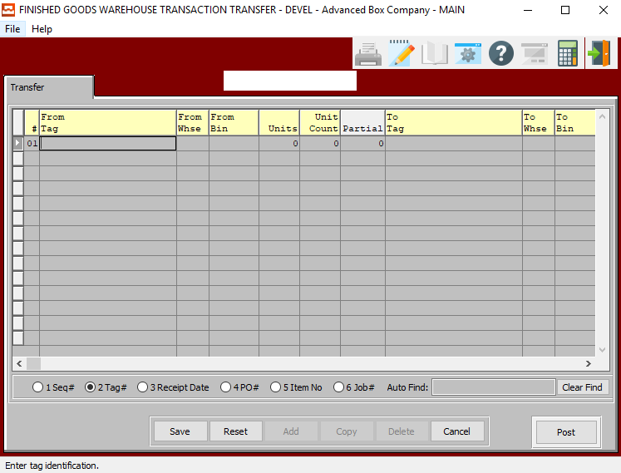

#### UPDATE

To update a Finished Goods transfer, simply double click the item or press the “***Update”*** button at the bottom of the screen. Press the “***Enter”*** key or click the “***Save”*** button to save the transaction. The “***F1”*** key may be used to find an appropriate purchase order number, job number, warehouse, and bin location or unit of measure.

#### ADD

To manually add Finished Goods transfers, press the “***Add”*** button at the bottom of the screen. Select any item by pressing “***F1”*** on the item code, then enter the remaining data and press the “***Enter”*** key or click the “***Save”*** button to save the transaction. The “***F1”*** key may be used to find an appropriate purchase order number, job number, warehouse, and bin location or unit of measure.

#### COPY

To copy a Finished Goods transfer, highlight the item with a single click, then press the “***Copy”*** button at the bottom of the screen. Press the “***Enter”*** key or click the “***Save”*** button to save the transaction. The “***F1”*** key may be used to find an appropriate purchase order number, job number, warehouse, and bin location or unit of measure.

#### DELETE

To delete a Finished Goods transfer, highlight the item with a single click, then press the “***Delete”*** button at the bottom of the screen. Press the “***Enter”*** key or click the “***Save”*** button to save the transaction. The “***F1”*** key may be used to find an appropriate purchase order number, job number, warehouse, and bin location or unit of measure.

#### POST

To Post a Finished Goods transfer, highlight each item with a single click, then press the “***POST”*** button at the bottom of the screen. Alternatively, the “***POST”*** button on the main menu may be used to post the entire batch of receipts, issues, transfers, adjustments and physical counts.

### Add Transfer

#### SAVE

Click the ***“Save”*** button to save all changes to the current Transfer.

#### RESET

Click the ***“Reset”*** button to reset all fields to their original state.

#### CANCEL

Click the ***“Cancel”*** button to cancel all changes to the Transfer without saving.

#### POST

To Post a Finished Goods transfer, highlight each item with a single click, then press the “***POST”*** button at the bottom of the screen. Alternatively, the “***POST”*** button on the main menu may be used to post the entire batch of receipts, issues, transfers, adjustments and physical counts.

### Add Transfer Field Definitions

#### From Tag / To Tag

Enter the beginning and ending Tag Number to transfer from and to, respectively.

#### From Warehouse / To Warehouse

Enter the beginning and ending Warehouse Location to transfer from and to, respectively.

#### From Bin / To Bin

Enter the beginning and ending Bin Number to transfer from and to, respectively.

#### Units

Enter the number of units received of the item into this bin in this warehouse.

#### Partial

Enter a partial quantity.

#### Customer #

This field will automatically fill as soon as the user chooses a Bin location. However, it can be modified by the user.

#### Job #

The job number defaults to the estimate number, but may be modified. The Job Factory Ticket will print by job number. Repeat jobs for an item will add a suffix to the original job number.

For example, a repeat job number could be Job number 88888-01 where 88888 is the original job and the 01 is the first repeat for that item.

All costs including, standard (estimated) labor, material and overhead, work in process, actual costs and variances are maintained by job number.

#### Job #: 00

Repeat jobs for an item will add a suffix to the original job number.

#### Item Number

Enter the Finished Good Item Number in this field. Alternatively, the Item Number field will automatically fill when the user selects their Tag Number.

The user can also press the ***“F1”*** key to search through all available Finished Goods items.

This list can be sorted by Item Number or Item Name. Alternatively, the user may search for any item that they wish to use in order to narrow down their selection.

Once an item is selected, this will automatically fill in several other fields with necessary information from the Item File.

#### Item Name

This description name transfers from the estimate for custom boxes, however it must be entered for stock boxes. This line transfers to the job ticket, purchase order, and numerous other reports. The system also uses the Item Name for alpha-Alphanumeric searches. This field will automatically populate once the user has selected or entered the item number, and cannot be modified further.

#### User Created

The username of the original user that created this receipt in the system.

#### User Updated

The username of the last user to have updated this receipt in the system.

#### Transfer Date

Enter the date that the item was transferred, defaults to system date. This field automatically defaults to today’s date, but may be modified by the user.

#### Transfer Time

The time that the new transfer is made. This defaults to the system time, but can be modified by the user.

### Transferring Partial Quantity

Transferring a partial tag will automatically create a new load tag. This tag is a copy of the scanned tag, with the quantity equal to the ((transferred units x count) + partial).

When transferring partial tags, the sharp-shooter software will prompt to create a new tag. The ***“Okay”*** button till create a new toad tag. The program will then prompt to print the new load tag. Click ***“Okay”*** to print the load tag immediately.

The net result will be two load tags with the units and counts split between the originally scanned pallet tag and the newly created pallet load tag.

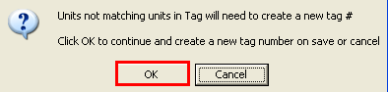

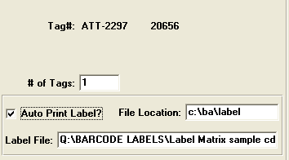

#### # of Tags

Enter the number of tags that you wish this particular tag to be split into.

#### Auto Print Label? – Toggle Box

To automatically print labels upon creation, make sure that the Auto Print Label toggle box is checked.

#### File Location

Enter the location of the file to be created. Alternatively, press the ***“F1”*** key to use the Windows Explorer window to choose the proper file path.

#### Label File

The user may enter the name of Label Matrix label file they wish to create. Alternatively, they may press the ***“F1”*** key to choose a file using the Windows Explorer window.

## Count Goods

### Overview

Finished Goods physical counts may be transferred to this file from the Top Gun batch data collection scanning device by pressing the “***IMPORT Physical Count”*** Button or physical counts may be scanned directly from the plant floor by pressing the “***SCAN PHYSICAL COUNTS”*** Button. Lastly, physical counts may be manually added to this file by searching for the item and tag number, then entering the correct quantity.

Once physical counts for each tag number have been imported or created, a list of counted records is shown for further updating, deletion and posting. Physical counts may be posted one at a time or in a batch via the “***POST”*** button. The list of items which were counted may be sorted by receipt date, purchase order number, item number and warehouse by clicking the appropriate circle at the bottom of the screen. To search alphabetically for an adjustment record, click the appropriate sort option, enter in a continuous string of characters in the Auto Find box, then press “***Enter”***.

### Browse Physical Counts

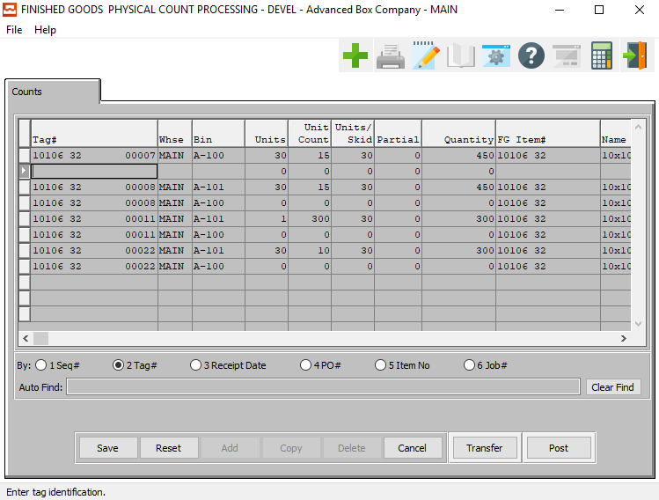

#### UPDATE

To update an items physical count, simply double click the item or press the “***Update”*** button at the bottom of the screen. Press the “***Enter”*** key or click the “***Save”*** button to save the transaction. The “***F1”*** key may be used to find an appropriate purchase order number, job number, warehouse, and bin location or unit of measure.

#### ADD

To manually add physical counts, press the “***Add”*** button at the bottom of the screen. Select any item by pressing “***F1”*** on the item code, then enter the remaining data and press the “***Enter”*** key or click the “***Save”*** button to save the transaction. The “***F1”*** key may be used to find an appropriate purchase order number, job number, warehouse, and bin location or unit of measure.

#### COPY

To copy a physical count record, highlight the item with a single click, then press the “***Copy”*** button at the bottom of the screen. Press the “***Enter”*** key or click the “***Save”*** button to save the transaction. The “***F1”*** key may be used to find an appropriate purchase order number, job number, warehouse, and bin location or unit of measure.

#### DELETE

To delete an items physical count, highlight the item with a single click, then press the “***Delete”*** button at the bottom of the screen. Press the “***Enter”*** key or click the “***Save”*** button to save the transaction. The “***F1”*** key may be used to find an appropriate purchase order number, job number, warehouse, and bin location or unit of measure.

#### TRANSFER

Click the ***“Transfer”*** button to confirm the transfer of the currently selected physical count.

#### POST

To Post a physical count record or batch, highlight each item with a single click, then press the “***POST”***  button at the bottom of the screen. Alternatively, the “***POST”*** button on the main menu may be used to post the entire batch of receipts, issues, transfers, adjustments and physic al counts.

### Add/Update Count

#### SAVE

Click the ***“Save”*** button to save all changes to the current Physical Count.

#### RESET

Click the ***“Reset”*** button to reset all fields to their original state.

#### CANCEL

Click the ***“Cancel”*** button to cancel all changes to the Physical Count without saving.

#### TRANSFER

Click the ***“Transfer”*** button to confirm the transfer of the currently selected physical count.

#### POST

To Post a physical count record or batch, highlight each item with a single click, then press the “***POST”*** button at the bottom of the screen. Alternatively, the “***POST”*** button on the main menu may be used to post the entire batch of receipts, issues, transfers, adjustments and physic al counts.

### Add/Update Count Field Definitions

#### Tag #

Enter a unique tag number for this Finished Good receipt.

A Warning Message should appear if the Tag Number already exists. This must be a unique number, otherwise the issue program will not know this tag number to select. The system now allows the user to enter the PO#, Line #, Qty, and then it duplicates the vendor tag #.

Alternatively, press the ***“F1”*** key to choose a valid Number from a list of available Tag Numbers.

#### Warehouse

This is the primary warehouse location for this item. The bin file will provide inventory control by warehouse, bin location and tag number. Enter the Primary Warehouse (loc). Alternatively, the user may press the ***“F1”*** key to select a warehouse from a list of available warehouses.

This list can be sorted by Location or Description. Alternatively, the user may search for any warehouse that they wish to use in order to narrow down their selection.

#### Bin

The bin location shows the location within the warehouse such as the aisle, bin location or floor location. Alternatively, the user may press the ***“F1”*** key to select the warehouse bin location information.

This list can be sorted by Warehouse or Bin. Alternatively, the user may search for any bin that they wish to use in order to narrow down their selection.

#### Units

Enter the number of units received of the item into this bin in this warehouse.

#### Units/Skid

Enter the number of units per skid.

#### Partial

Enter a partial quantity.

#### Quantity

Enter the quantity in this warehouse, bin, and tag for the item with this job number.

#### FG Item #

Enter the Finished Good Item Number in this field. Alternatively, the Item Number field will automatically fill when the user selects their Tag Number.

The user can also press the ***“F1”*** key to search through all available Finished Goods items.

This list can be sorted by Item Number or Item Name. Alternatively, the user may search for any item that they wish to use in order to narrow down their selection.

Once an item is selected, this will automatically fill in several other fields with necessary information from the Item File.

#### Item Name

This description name transfers from the estimate for custom boxes, however it must be entered for stock boxes. This line transfers to the job ticket, purchase order, and numerous other reports. The system also uses the Item Name for alpha-Alphanumeric searches. This field will automatically populate once the user has selected or entered the item number, and cannot be modified further.

#### Job #

The job number defaults to the estimate number, but may be modified. The Job Factory Ticket will print by job number. Repeat jobs for an item will add a suffix to the original job number.

For example, a repeat job number could be Job number 88888-01 where 88888 is the original job and the 01 is the first repeat for that item.

All costs including, standard (estimated) labor, material and overhead, work in process, actual costs and variances are maintained by job number.

#### Job #: 00

Repeat jobs for an item will add a suffix to the original job number.

#### Count Date

Enter the date that the item was counted, defaults to system date. This field automatically defaults to today’s date, but may be modified by the user.

#### Count Time

The time that the new count is made. This defaults to the system time, but can be modified by the user.

#### Created By

The username of the original user that created this receipt in the system.

#### Last Update

The username of the last user to have updated this receipt in the system.

#### Sequence #

The Sequence Number is automatically given by the system. It is not modifiable by the user.

#### PO #

This field is for the Order Number of Purchased Finished Goods only. The number entered must be a valid PO# from the ASI Purchasing Module. The user may enter a PO Number, or press the ***“F1”*** key to select the PO # from a list of all available Purchase Orders.

This list can be sorted by PO Number, Vendor Item, or Item Number. Alternatively, the user may search for a PO #, Vendor Item, or Item # that they wish to use in order to narrow down their selection.

## Delete Goods

The ***“Delete”*** button creates a negative receipt, which will offset the positive receipt, thereby making Quantity Produced = 0, and Quantity on hand = 0. The user can only scan tags that have a positive on-hand balance.

### Receipts

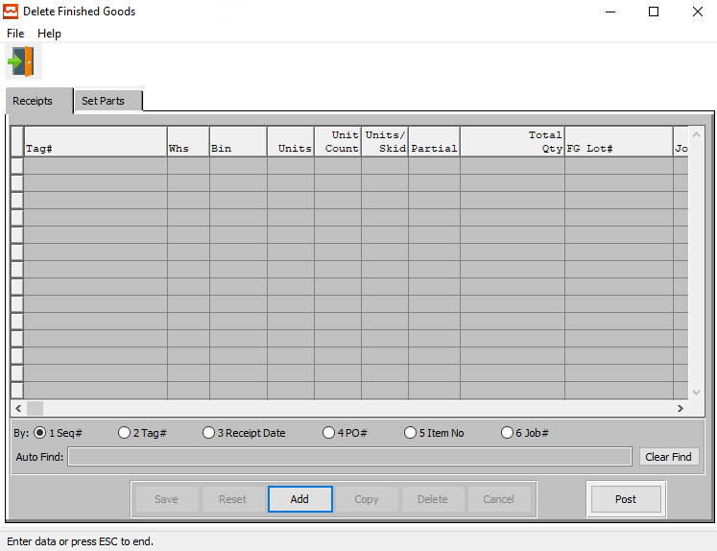

#### ADD

Click the ***“Add”*** button at the bottom of the screen to add a new Deletion Receipt.

#### POST

To post a receipt deletion, highlight each item with a single click, and then press the “***POST”*** button at the bottom of the screen. Alternatively, the “***POST”*** button on the main menu may be used to post the entire batch of receipts, issues, transfers, adjustments and physical counts.

### Add Receipt

#### SAVE

Click the ***“Save”*** button to save all changes to the current Receipt.

#### RESET

Click the ***“Reset”*** button to reset all fields to their original state.

#### CANCEL

Click the ***“Cancel”*** button to cancel all changes to the Receipt without saving.

#### POST

To post a receipt deletion, highlight each item with a single click, and then press the “***POST”*** button at the bottom of the screen. Alternatively, the “***POST”*** button on the main menu may be used to post the entire batch of receipts, issues, transfers, adjustments and physical counts.

### Add Receipt Field Definitions

#### Tag #

Enter a unique tag number for this Finished Good receipt.

A Warning Message should appear if the Tag Number already exists. This must be a unique number, otherwise the issue program will not know this tag number to select. The system now allows the user to enter the PO#, Line #, Qty, and then it duplicates the vendor tag #.

Alternatively, press the ***“F1”*** key to choose a valid Number from a list of available Tag Numbers.

#### Warehouse

This is the primary warehouse location for this item. The bin file will provide inventory control by warehouse, bin location and tag number. Enter the Primary Warehouse (loc). Alternatively, the user may press the ***“F1”*** key to select a warehouse from a list of available warehouses.

This list can be sorted by Location or Description. Alternatively, the user may search for any warehouse that they wish to use in order to narrow down their selection.

#### Bin

The bin location shows the location within the warehouse such as the aisle, bin location or floor location. Alternatively, the user may press the ***“F1”*** key to select the warehouse bin location information.

This list can be sorted by Warehouse or Bin. Alternatively, the user may search for any bin that they wish to use in order to narrow down their selection.

#### Units

Enter the number of units received of the item into this bin in this warehouse.

#### Units/Skid

Enter the number of units per skid.

#### Partial

Enter a partial quantity.

#### Total Qty

The Total Quantity is automatically calculated by the system using the Units, Unit Count, and Units/Skid fields. This field is not directly modifiable by the user, but it will update if the user changes the information in any of the aforementioned fields.

#### FG Lot #

Enter the lot number for this Finished Good

#### Job #

The job number defaults to the estimate number, but may be modified. The Job Factory Ticket will print by job number. Repeat jobs for an item will add a suffix to the original job number.

For example, a repeat job number could be Job number 88888-01 where 88888 is the original job and the 01 is the first repeat for that item.

All costs including, standard (estimated) labor, material and overhead, work in process, actual costs and variances are maintained by job number.

#### Job #: 00

Repeat jobs for an item will add a suffix to the original job number.

#### PO #

This field is for the Order Number of Purchased Finished Goods only. The number entered must be a valid PO# from the ASI Purchasing Module. The user may enter a PO Number, or press the ***“F1”*** key to select the PO # from a list of all available Purchase Orders.

This list can be sorted by PO Number, Vendor Item, or Item Number. Alternatively, the user may search for a PO #, Vendor Item, or Item # that they wish to use in order to narrow down their selection.

#### Item #

Enter the Finished Good Item Number in this field. Alternatively, the Item Number field will automatically fill when the user selects their Tag Number.

The user can also press the ***“F1”*** key to search through all available Finished Goods items.

This list can be sorted by Item Number or Item Name. Alternatively, the user may search for any item that they wish to use in order to narrow down their selection.

Once an item is selected, this will automatically fill in several other fields with necessary information from the Item File.

#### Item Name

This description name transfers from the estimate for custom boxes, however it must be entered for stock boxes. This line transfers to the job ticket, purchase order, and numerous other reports. The system also uses the Item Name for alpha-Alphanumeric searches. This field will automatically populate once the user has selected or entered the item number, and cannot be modified further.

#### Cost / UOM

Enter the cost of the item. Three methods for determining the cost of an item exist; Standard Cost, Last Cost, and Average Cost. The company enters the costing method, that they want to use in the *F/G* Control file.

#### UOM

The sell price unit of measure defaults to M for per thousand, however this may be modified. Each unit of measure will yield a different total selling price.

Valid Units of Measure are:

|  |  |
| --- | --- |
| C | Per Hundred |
| CS | Per Case |
| EA | Per Each |
| L | Per Lot |
| M | Per Thousand |

#### Freight Cost

Enter the total freight amount for the Bill of Lading. If the weight per pallet or total Bill of Lading weight is entered in addition to the freight cost per hundred weight, the total freight cost is calculated.

#### Extended Cost

The cost for this Unit of Measure defaults from Raw Material, but may be modified by the user.

#### Sequence #

The Sequence Number is automatically given by the system. It is not modifiable by the user.

#### Receipt Date

Enter the date that the item was received, defaults to system date. This field automatically defaults to today’s date, but may be modified by the user.

### Set Parts

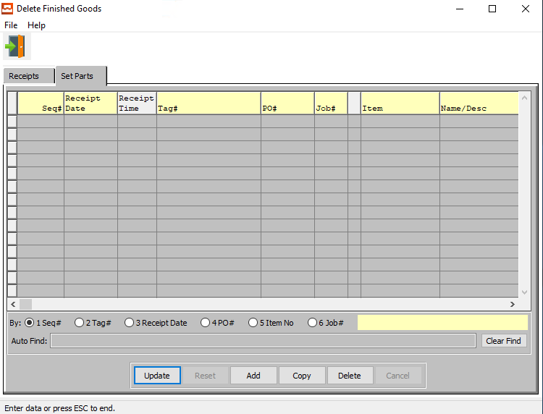

#### UPDATE

To change the currently selected Set Part, simply click the ***“Update***” button at the bottom of the screen.

#### ADD

Click the ***“Add”*** button at the bottom of the screen to add a new Set Part.

#### COPY

Click the ***“Copy”*** button to copy information from the currently selected Set Part.

#### DELETE

To delete the currently selected Set Part, simply press the ***"D"*** key. Alternatively, click the ***“Delete”*** button at the bottom of the screen.

### Add/Update Set Parts

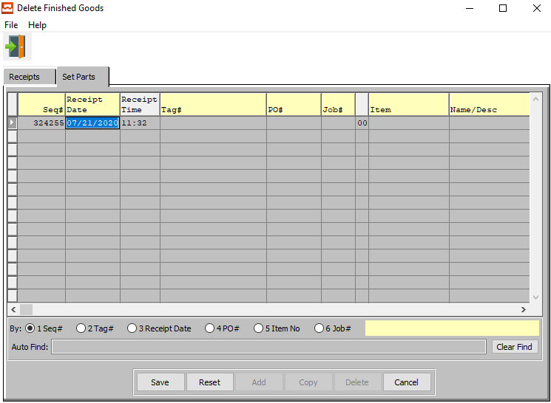

#### SAVE

Click the ***“Save”*** button to save all changes to the current Set Part.

#### RESET

Click the ***“Reset”*** button to reset all fields to their original state.

#### CANCEL

Click the ***“Cancel”*** button to cancel all changes to the Set Part without saving.

### Add/Update Set Part Field Definitions

#### Sequence #

The Sequence Number is automatically given by the system. It is not modifiable by the user.

#### Receipt Date

Enter the date that the item was received, defaults to system date. This field automatically defaults to today’s date, but may be modified by the user.

#### Receipt Time

The time that the new receipt is made. This defaults to the system time, but can be modified by the user.

#### Tag #

Enter a unique tag number for this Finished Good receipt.

A Warning Message should appear if the Tag Number already exists. This must be a unique number, otherwise the issue program will not know this tag number to select. The system now allows the user to enter the PO#, Line #, Qty, and then it duplicates the vendor tag #.

Alternatively, press the ***“F1”*** key to choose a valid Number from a list of available Tag Numbers.

#### PO #

This field is for the Order Number of Purchased Finished Goods only. The number entered must be a valid PO# from the ASI Purchasing Module. The user may enter a PO Number, or press the ***“F1”*** key to select the PO # from a list of all available Purchase Orders.

This list can be sorted by PO Number, Vendor Item, or Item Number. Alternatively, the user may search for a PO #, Vendor Item, or Item # that they wish to use in order to narrow down their selection.

#### Job #

The job number defaults to the estimate number, but may be modified. The Job Factory Ticket will print by job number. Repeat jobs for an item will add a suffix to the original job number.

For example, a repeat job number could be Job number 88888-01 where 88888 is the original job and the 01 is the first repeat for that item.

All costs including, standard (estimated) labor, material and overhead, work in process, actual costs and variances are maintained by job number.

#### Job #: 00

Repeat jobs for an item will add a suffix to the original job number.

#### Item

Enter the Finished Good Item Number in this field. Alternatively, the Item Number field will automatically fill when the user selects their Tag Number.

The user can also press the ***“F1”*** key to search through all available Finished Goods items.

This list can be sorted by Item Number or Item Name. Alternatively, the user may search for any item that they wish to use in order to narrow down their selection.

Once an item is selected, this will automatically fill in several other fields with necessary information from the Item File.

#### Item Name/Description

This description name transfers from the estimate for custom boxes, however it must be entered for stock boxes. This line transfers to the job ticket, purchase order, and numerous other reports. The system also uses the Item Name for alpha-Alphanumeric searches. This field will automatically populate once the user has selected or entered the item number, and cannot be modified further.

#### Warehouse

This is the primary warehouse location for this item. The bin file will provide inventory control by warehouse, bin location and tag number. Enter the Primary Warehouse (loc). Alternatively, the user may press the ***“F1”*** key to select a warehouse from a list of available warehouses.

This list can be sorted by Location or Description. Alternatively, the user may search for any warehouse that they wish to use in order to narrow down their selection.

#### Bin

The bin location shows the location within the warehouse such as the aisle, bin location or floor location. Alternatively, the user may press the ***“F1”*** key to select the warehouse bin location information.

This list can be sorted by Warehouse or Bin. Alternatively, the user may search for any bin that they wish to use in order to narrow down their selection.

#### Units

Enter the number of units received of the item into this bin in this warehouse.

#### Unit per Pallet

Enter the number of units per pallet.

#### Partial

Enter a partial quantity.

#### Cost / UOM

Enter the cost of the item. Three methods for determining the cost of an item exist; Standard Cost, Last Cost, and Average Cost. The company enters the costing method, that they want to use in the *F/G* Control file.

#### UOM

The sell price unit of measure defaults to M for per thousand, however this may be modified. Each unit of measure will yield a different total selling price.

Valid Units of Measure are:

|  |  |
| --- | --- |
| C | Per Hundred |
| CS | Per Case |
| EA | Per Each |
| L | Per Lot |
| M | Per Thousand |

#### Total QTY

The Total Quantity is automatically calculated by the system using the Units, Unit Count, and Units/Skid fields. This field is not directly modifiable by the user, but it will update if the user changes the information in any of the aforementioned fields.

#### Freight Cost

Enter the total freight amount for the Bill of Lading. If the weight per pallet or total Bill of Lading weight is entered in addition to the freight cost per hundred weight, the total freight cost is calculated.

#### Extended Cost

The cost for this Unit of Measure defaults from Raw Material, but may be modified by the user.

#### FG Lot #

Enter the lot number for this Finished Good

#### Created By

The username of the original user that created this receipt in the system.

#### Last Update

The username of the last user to have updated this receipt in the system.

#### Total Weight

The Total Weight is automatically calculated by the system using the Cost/UOM and UOM fields. This field is not directly modifiable by the user, but it will update if the user changes the information in either of the ‘Cost/UOM’ or ‘UOM’ fields.

## Return Goods

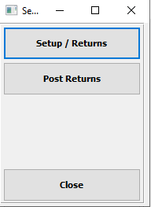

#### Setup / Returns

Click the ***“Setup/Returns”*** button to open the *Setup Returns Sharp Shooter* screen.

#### Post Returns

Click the ***“Post Returns”*** button to open the *Post Returns Sharp Shooter* screen.

#### CLOSE

Click the ***“Close”*** button to exit the Return Goods Sharp Shooter Menu.

### Setup / Returns

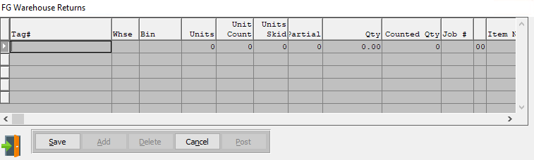

#### ADD

Click the ***“Add”*** button at the bottom of the screen to add a new Finished Good Warehouse Return.

#### EXIT

Click the ***“Exit Door Icon”*** to exit the Finished Good Warehouse Returns popup screen.

### Add Return

#### SAVE

Click the ***“Save”*** button to save all changes to the current Warehouse Return.

#### CANCEL

Click the ***“Cancel”*** button to cancel all changes to the Warehouse Return without saving.

### Add Return Field Definitions

#### Tag #

Enter a unique tag number for this Finished Good receipt.

A Warning Message should appear if the Tag Number already exists. This must be a unique number, otherwise the issue program will not know this tag number to select. The system now allows the user to enter the PO#, Line #, Qty, and then it duplicates the vendor tag #.

Alternatively, press the ***“F1”*** key to choose a valid Number from a list of available Tag Numbers.

#### Warehouse

This is the primary warehouse location for this item. The bin file will provide inventory control by warehouse, bin location and tag number. Enter the Primary Warehouse (loc). Alternatively, the user may press the ***“F1”*** key to select a warehouse from a list of available warehouses.

This list can be sorted by Location or Description. Alternatively, the user may search for any warehouse that they wish to use in order to narrow down their selection.

#### Bin

The bin location shows the location within the warehouse such as the aisle, bin location or floor location. Alternatively, the user may press the ***“F1”*** key to select the warehouse bin location information.

This list can be sorted by Warehouse or Bin. Alternatively, the user may search for any bin that they wish to use in order to narrow down their selection.

#### Units

Enter the number of units received of the item into this bin in this warehouse.

#### Units / Skid

Enter the number of units per skid.

#### Partial

Enter a partial quantity.

#### Qty

This is the current quantity of this item. It will automatically transfer from the Item file as soon as the user enters or chooses a valid Tag number.

#### Counted Qty

The user may enter the quantity of this item that was physically counted.

#### Job #

The job number defaults to the estimate number, but may be modified. The Job Factory Ticket will print by job number. Repeat jobs for an item will add a suffix to the original job number.

For example, a repeat job number could be Job number 88888-01 where 88888 is the original job and the 01 is the first repeat for that item.

All costs including, standard (estimated) labor, material and overhead, work in process, actual costs and variances are maintained by job number.

#### Job #: 00

Repeat jobs for an item will add a suffix to the original job number.

#### Item Number

Enter the Finished Good Item Number in this field. Alternatively, the Item Number field will automatically fill when the user selects their Tag Number.

The user can also press the ***“F1”*** key to search through all available Finished Goods items.

This list can be sorted by Item Number or Item Name. Alternatively, the user may search for any item that they wish to use in order to narrow down their selection.

Once an item is selected, this will automatically fill in several other fields with necessary information from the Item File.

#### Item Name

This description name transfers from the estimate for custom boxes, however it must be entered for stock boxes. This line transfers to the job ticket, purchase order, and numerous other reports. The system also uses the Item Name for alpha-Alphanumeric searches. This field will automatically populate once the user has selected or entered the item number, and cannot be modified further.

#### Cost

Enter the cost of the item. Three methods for determining the cost of an item exist; Standard Cost, Last Cost, and Average Cost. The company enters the costing method, that they want to use in the *F/G* Control file.

#### Cost UOM

The sell price unit of measure defaults to M for per thousand, however this may be modified. Each unit of measure will yield a different total selling price.

Valid Units of Measure are:

|  |  |
| --- | --- |
| C | Per Hundred |
| CS | Per Case |
| EA | Per Each |
| L | Per Lot |
| M | Per Thousand |

#### Extended Cost

The cost for this Unit of Measure defaults from Raw Material, but may be modified by the user.

#### User Created

The username of the original user that created this receipt in the system.

#### User Updated

The username of the last user to have updated this receipt in the system.

#### Count Date

Enter the date that the item was counted, defaults to system date. This field automatically defaults to today’s date, but may be modified by the user.

#### Count Time

The time that the new count is made. This defaults to the system time, but can be modified by the user.

## Post Goods

### Selection Parameters

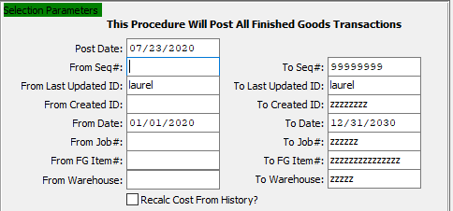

#### Post Date

Enter the post date of the Finished Items Goods file. This defaults as today’s date, but may be modified.

#### From Sequence # / To Sequence #

Enter the beginning and ending Sequence Number to Post Goods for.

#### From Last Updated ID / To Last Updated ID

Enter the beginning and ending Last Updated User ID to Post Goods for.

#### From Created ID / To Created ID

Enter the beginning and ending Created User ID to Post Goods for.

#### From Date / To Date

Enter the beginning and ending Date to Post Goods for.

#### From Job # / To Job #

Enter the beginning and ending Job Number to Post Goods for.

#### From FG Item # / To FG Item #

Enter the beginning and ending Finished Good Item Number to Post Goods for.

#### From Warehouse / To Warehouse

Enter the beginning and ending Warehouse to Post Goods for.

#### Recalc Cost from History? – Toggle Box

To recalculate the cost of the finished goods transaction from history, make sure that this toggle box is checked.

### Transaction Type and Sort Options

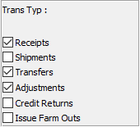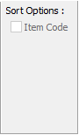

#### Receipts – Toggle Box

To include Receipts in the edit list, make sure that the Receipts toggle box is checked.

#### Shipments – Toggle Box

To include Shipments in the edit list, make sure that the Shipments toggle box is checked.

#### Transfers – Toggle Box

To include Transfers in the edit list, make sure that the Transfers toggle box is checked.

#### Adjustments – Toggle Box

To include Adjustments in the edit list, make sure that the Adjustments toggle box is checked.

#### Credit Returns – Toggle Box

To include Credit Returns in the edit list, make sure that the Credit Returns toggle box is checked.

#### Issue Farm Outs – Toggle Box

To include Farm Outs in the edit list, make sure that the Issue Farm Outs toggle box is checked.

#### Item Code – Toggle Box

To Sort transactions by their item code, the user must enter int the starting and beginning Finished Good Item Numbers in the selection parameters above, then make sure that the Item Code toggle box is checked.

### Print Options

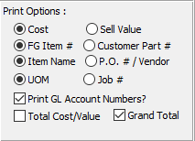

#### Fields (Choice)

The user may choose the options that they wish to print using this list. All options where the desired option choice bubble is toggled will post to the Finished Goods file, and print on the subsequent report.

#### Print GL Account Numbers? – Toggle Box

To print General Ledger account numbers on the report, make sure that this toggle box is checked.

#### Total Cost/Value – Toggle Box

To print the total cost and value on the report, make sure that the Total Cost/Value toggle box is checked.

#### Grand Total – Toggle Box

To print the grand total on the report, make sure that the Grand Total toggle box is checked.

### Output Destination

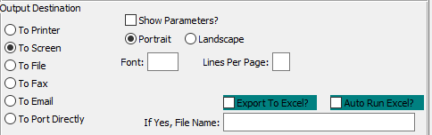

#### Destination Choice

To choose the destination where the document should be printed, please make sure that desired output destination choice bubble is toggled.

#### Layout Choice

To choose the preferred layout of Landscape vs. Portrait, please make sure the desired option choice bubbled is toggled.

#### Lines Per Page

Lines per page on the report when printing.

#### Font

Enter the font number to use with this report (Font 11 is default).

#### Show Parameters? – Toggle Box

To show parameters, make sure that the toggle box is ‘ticked’ with a checkmark.

#### Export to Excel? – Toggle Box

To export the printed file to an excel document, make sure that the Export to Excel toggle box is checked.

#### Auto Run Excel? – Toggle Box

To automatically open the new excel document, make sure that the Auto Run Excel toggle box is checked.

#### If Yes, File Name

If exporting the file to Excel, enter the desired file name.

## Consolidate Tags

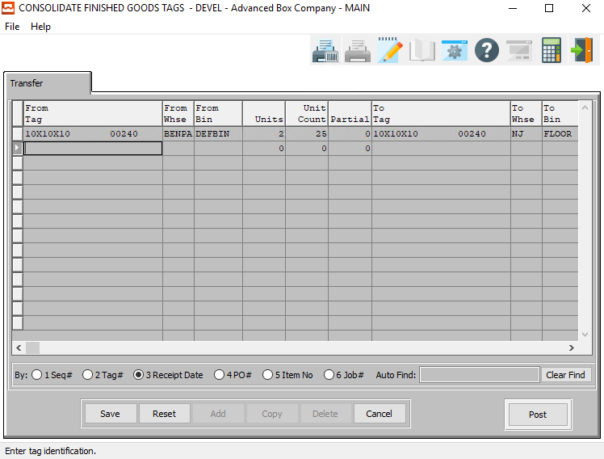

#### UPDATE

To change the currently selected Finished Good Tag Consolidation, simply click the ***“Update***” button at the bottom of the screen.

#### ADD

Click the ***“Add”*** button at the bottom of the screen to add a new Finished Good Tag Consolidation.

#### COPY

Click the ***“Copy”*** button to copy information from the currently selected Finished Good Tag Consolidation.

#### DELETE

To delete the currently selected Finished Good Tag Consolidation, simply press the ***"D"*** key. Alternatively, click the ***“Delete”*** button at the bottom of the screen.

#### POST

To post a tag consolidation, highlight each item with a single click, and then press the “***POST”*** button at the bottom of the screen. Alternatively, the “***POST”*** button on the main menu may be used to post the entire batch of receipts, issues, transfers, adjustments and physical counts.

### Add Finished Good Tags

#### SAVE

Click the ***“Save”*** button to save all changes to the current Transfer.

#### RESET

Click the ***“Reset”*** button to reset all fields to their original state.

#### CANCEL

Click the ***“Cancel”*** button to cancel all changes to the Transfer without saving.

#### POST

To post a tag consolidation, highlight each item with a single click, and then press the “***POST”*** button at the bottom of the screen. Alternatively, the “***POST”*** button on the main menu may be used to post the entire batch of receipts, issues, transfers, adjustments and physical counts.

### Add Finished Good Tags Field Definitions

#### From Tag / To Tag

Enter the beginning and ending Tag Number to Add a Finished Good Tag for.

#### From Warehouse / To Warehouse

Enter the beginning and ending Warehouse to Add a Finished Good Tag for.

#### From Bin / To Bin

Enter the beginning and ending Bin Number to Add a Finished Good Tag for.

#### Units

Enter the number of units received of the item into this bin in this warehouse.

#### Customer #

This field will automatically fill as soon as the user chooses a Bin location. However, it can be modified by the user.

#### Job #

The job number defaults to the estimate number, but may be modified. The Job Factory Ticket will print by job number. Repeat jobs for an item will add a suffix to the original job number.

For example, a repeat job number could be Job number 88888-01 where 88888 is the original job and the 01 is the first repeat for that item.

All costs including, standard (estimated) labor, material and overhead, work in process, actual costs and variances are maintained by job number.

#### Job #: 00

Repeat jobs for an item will add a suffix to the original job number.

#### Item Number

Enter the Finished Good Item Number in this field. Alternatively, the Item Number field will automatically fill when the user selects their Tag Number.

The user can also press the ***“F1”*** key to search through all available Finished Goods items.

This list can be sorted by Item Number or Item Name. Alternatively, the user may search for any item that they wish to use in order to narrow down their selection.

Once an item is selected, this will automatically fill in several other fields with necessary information from the Item File.

#### Item Name

This description name transfers from the estimate for custom boxes, however it must be entered for stock boxes. This line transfers to the job ticket, purchase order, and numerous other reports. The system also uses the Item Name for alpha-Alphanumeric searches. This field will automatically populate once the user has selected or entered the item number, and cannot be modified further.

#### User Created

The username of the original user that created this receipt in the system.

#### User Updated

The username of the last user to have updated this receipt in the system.

#### Transfer Date

Enter the date that the item was transferred, defaults to system date. This field automatically defaults to today’s date, but may be modified by the user.

#### Transfer Time

The time that the new transfer is made. This defaults to the system time, but can be modified by the user.

# **Bill of Lading Transaction [BB]**

## Overview

Finished Goods tag numbers may be scanned directly from Finished Goods onto the bill of lading file. Once the tag numbers have been transferred, the list of bills of lading and tag numbers are shown in this file for updating, deletion and posting. Issues may be posted one at a time or in a batch via the “***POST”*** button. The list of issues may be sorted by receipt date, purchase order number, item number and warehouse by clicking the appropriate circle at the bottom of the screen. To search alphabetically, click the appropriate sort option, enter in a continuous string of characters in the Auto Find box, then press “***Enter”***.

### Main Menu

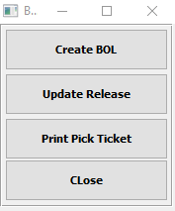

#### Create BOL

Click the ***“Create BOL”*** button to open the *Create BOL Sharp Shooter* screen.

#### Update Release

Click the ***“Update Release”*** button to open the *Update Release Sharp Shooter* screen.

#### Print Pick Ticket

Click the ***“Print Pick Ticket”*** button to open the *Print Pick Ticket Sharp Shooter* screen.

#### CLOSE

Click the ***“Close”*** button to exit the Bill of Lading Transactions Sharp Shooter Main Menu.

## Create BOL

### Overview

Bar Coded Load Tags may be scanned as shipment records on a bill of lading by pressing the “***Scan Bill of Lading”*** Button. Once the user selects the bill of lading number, each tag number scanned will update the bill of lading lines file. The job number, item number, order number, warehouse, bin location and count will transfer directly to the bill of lading from the tag number. Once the bill of lading is completed, the bill of lading should be printed and then posted.

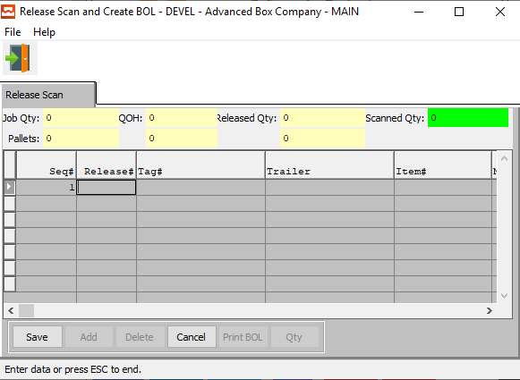

#### ADD

Click the ***“Add”*** button at the bottom of the screen to add a new release scan.

### Add BOL

#### SAVE

Click the ***“Save”*** button to save all changes to the current Release Scan.

#### CANCEL

Click the ***“Cancel”*** button to cancel all changes to the Release Scan without saving.

### Add BOL Field Definitions

#### Sequence #

The Sequence Number is automatically given by the system. It is not modifiable by the user.

#### Release #

Enter the release number to add to the Bill of Lading. In change mode, the “***F1”*** or the ***“Page Up”*** / ***“Page Down”*** keys will search for an existing release number. Highlight the desired release number and press ***“Enter”*** to add the release to the Bill of Lading.

#### Tag #

Enter a Tag Number to search for. Alternatively, press the ***“F1”*** key to choose a valid Number from a list of available Tag Numbers.

#### Trailer

Enter the common carrier vehicle id or tag number.

#### Item #

Enter the Finished Good Item Number in this field. Alternatively, the Item Number field will automatically fill when the user selects their Tag Number.

The user can also press the ***“F1”*** key to search through all available Finished Goods items.

This list can be sorted by Item Number or Item Name. Alternatively, the user may search for any item that they wish to use in order to narrow down their selection.

Once an item is selected, this will automatically fill in several other fields with necessary information from the Item File.

#### Item Name

This description name transfers from the estimate for custom boxes, however it must be entered for stock boxes. This line transfers to the job ticket, purchase order, and numerous other reports. The system also uses the Item Name for alpha-Alphanumeric searches. This field will automatically populate once the user has selected or entered the item number, and cannot be modified further.

#### Order #

Enter order number or you may use the ***“F1”*** key look-up. A partial description may be typed into any field or data may be entered into multiple fields followed by pressing the ***“Go”*** button to sort the fields by the criteria that was entered. Once the data is presented on the screen, the YELLOW column heading may be clicked to sort that specific column in ascending or descending order.

#### Warehouse

This is the primary warehouse location for this item. The bin file will provide inventory control by warehouse, bin location and tag number. Enter the Primary Warehouse (loc). Alternatively, the user may press the ***“F1”*** key to select a warehouse from a list of available warehouses.

This list can be sorted by Location or Description. Alternatively, the user may search for any warehouse that they wish to use in order to narrow down their selection.

#### Bin

The bin location shows the location within the warehouse such as the aisle, bin location or floor location. Alternatively, the user may press the ***“F1”*** key to select the warehouse bin location information.

This list can be sorted by Warehouse or Bin. Alternatively, the user may search for any bin that they wish to use in order to narrow down their selection.

#### Customer #

This field will automatically fill as soon as the user chooses a Bin location. However, it can be modified by the user.

#### Units

Enter the number of units received of the item into this bin in this warehouse.

#### Unit per Pallet

Enter the number of units per pallet.

#### Partial

Enter a partial quantity.

#### Quantity

Enter the quantity in this warehouse, bin, and tag for the item with this job number.

### Print BOL

To Post a bill of lading, highlight each item with a single click, then press the “***POST”*** button at the bottom of the screen. Alternatively, the “***POST”*** button on the main menu may be used to post the entire batch of receipts, issues, transfers, adjustments and physical counts.

## Update Release

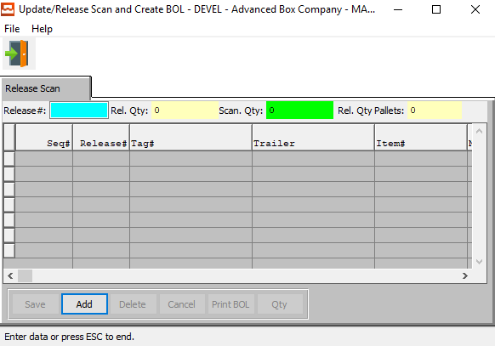

#### ADD

Click the ***“Add”*** button at the bottom of the screen to add a new Release Scan.

#### Release #

Enter a release number to search for.

## Print Pick Ticket

### Selection Parameters

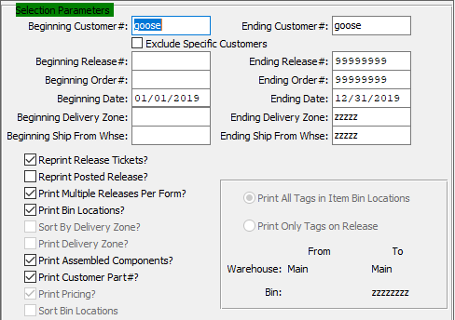

#### Beginning Customer # / Ending Customer #

Enter the beginning and ending Customer Number to Print a Pick Ticket for.

#### Exclude Specific Customers – Toggle Box

To exclude specific customers from the selection, make sure that this toggle box is checked.

#### Beginning Release # / Ending Release #

Enter the beginning and ending Release Number to Print a Pick Ticket for.

#### Beginning Order # / Ending Order #

Enter the beginning and ending Order Number to Print a Pick Ticket for.

#### Beginning Date / Ending Date

Enter the beginning and ending Order Date to Print a Pick Ticket for.

#### Beginning Delivery Zone / Ending Delivery Zone

Enter the beginning and ending Delivery Zone to Print a Pick Ticket for.

#### Beginning Ship From Warehouse / Ending Ship From Warehouse

Enter the beginning and ending Ship-From Warehouse to Print a Pick Ticket for.

#### Reprint Release Tickets? – Toggle Box

To reprint a release ticket, make sure that the Reprint Release Tickets toggle box is checked.

#### Reprint Posted Release? – Toggle Box

To reprint a posted release, make sure that this toggle box is checked.

#### Print Multiple Releases per Form? – Toggle Box

To print multiple releases, make sure that this toggle box is checked.

#### Print Bin Locations? – Toggle Box

To print bin locations, make sure that the Print Bin Locations toggle box is checked.

#### Sort by Delivery Zone? – Toggle Box

To sort selections by delivery zone, make sure that the Sort by Delivery Zone toggle box is checked.

#### Print Delivery Zone? – Toggle Box

To print the delivery zone, make sure that the Print Delivery Zone toggle box is checked.

#### Print Assembled Components? – Toggle Box

To print the assembled components, make sure that this toggle box is checked.

#### Print Customer Part #? – Toggle Box

To print the customer part number, make sure that this toggle box is checked.

#### Print Pricing? – Toggle Box

To print pricing, make sure that the Print Pricing toggle box is checked.

#### Sort Bin Locations – Toggle Box

To sort bin locations, make sure that the Sort Bin Locations toggle box is checked.

#### Print Tags (Choice)

To choose the preferred print option, please make sure the desired option choice bubble is toggled.

#### From Warehouse / To Warehouse

Enter the beginning and ending Warehouse to Print a Pick Ticket for.

#### From Bin / To Bin

Enter the beginning and ending Bin Number to Print a Pick Ticket for.

### Output Destination

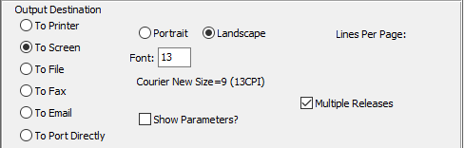

#### Destination Choice

To choose the destination where the document should be printed, please make sure that desired output destination choice bubble is toggled.

#### Layout Choice

To choose the preferred layout of Landscape vs. Portrait, please make sure the desired option choice bubbled is toggled.

#### Lines Per Page

Lines per page on the report when printing.

#### Font

Enter the font number to use with this report (Font 13 is default).

#### Show Parameters? – Toggle Box

To show parameters, make sure that the toggle box is ‘ticked’ with a checkmark.

#### Multiple Releases – Toggle Box

To print multiple releases, make sure that the Multiple Releases toggle box is checked.

# **Label Menu [BL]**

## Overview

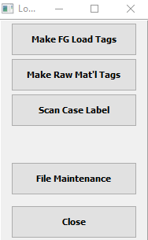

#### Make Finished Good Load Tags

Click the ***“Make FG Load Tags”*** button to open the *Create Finished Good Load Tags Sharp Shooter* screen.

#### Make Raw Material Tags

Click the ***“Make Raw Mat’l Tags”*** button to open the *Create Raw Materials Load Tags Sharp Shooter* screen.

#### Scan Case Label

Click the ***“Scan Case Label”*** button to open the *Case Label Sharp Shooter* screen.

#### File Maintenance

Click the ***“File Maintenance”*** button to open the *Tag Maintenance Selection Sharp Shooter* Menu screen.

#### CLOSE

Click the ***“Close”*** button to exit the Label/Load Tags Sharp Shooter Main Menu.

## Make Finished Good Load Tags

Load tags may be created for purchased finished goods upon receipt, from production finishing or in the office. Load tags for Inventory that is stocked in corrugated cases may be created by scanning the bar code on the case label. Alternatively, the job number may be scanned for a job card or the use may enter the order number, job number or item code.

Once entered, the program generates a worksheet so that the receiving clerk will type the number of tags, quantity per pallet, quantity per case or bundle, units per pallet and any partial unit quantity. Once the “***CREATE TAGS”*** button is pressed, the load tags are created and printed, and may simultaneously create Finished Goods receipts in the Advantzware system. The receipts file is the ***“N”-“K”-“1”*** FGReceipt parameter is set to LOADTAG. The number of load tags per pallet may be defined for each customer or a default number per pallet may be set in the ***“N”-“K”-“1”*** LOADTAG parameter.

Once the load tags are printed, they will be attached to each pallet. The load tag will show the purchase order number, item number, job number, unit count and a bar code load tag number, which is created by combining the purchase order number, line number, unit number and unit count for each pallet received. Alternatively, a vendor supplied load tag may be scanned, which will create the warehouse receipt. Receipts for Finished Goods without bar coded tags may be added via the “***Enter/Modify Receipts”*** button.

### Selection Parameters

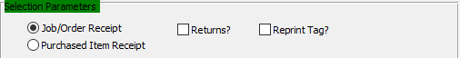

#### Receipt Type (Choice)

To choose the preferred receipt method of Job/Order vs. Purchased Item, please make sure the desired option choice bubble is toggled.

#### Returns? – Toggle Box

To create a load tag for a return, make sure that the Returns toggle box is checked.

#### Reprint Tag? – Toggle Box

If this is a reprint of an existing tag, make sure that the Reprint Tag toggle box is checked.

### Data Parameters

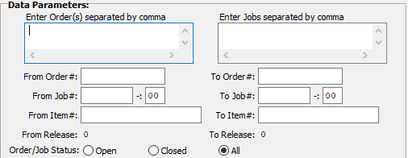

#### Enter Order(s) Separated by Comma

If the orders the user wishes to create load tags for are not sequential, the user may enter in the individual orders they wish to create load tags for. Each must be separated by a comma.

#### Enter Job(s) Separated by Comma

If the jobs the user wishes to create load tags for are not sequential, the user may enter in the individual orders they wish to create load tags for. Each must be separated by a comma.

#### From Order # / To Order #

Enter the starting and ending order number create load tags for.

#### From Job # / To Job #

Enter the starting and ending job number create load tags for.

#### From Job #: 00 / To Job #: 00

Enter the sequential starting and ending number for the job to create load tags for.

#### From Item # / To Item #

Enter the starting and ending item number create load tags for.

#### Order/Job Status (Choice)

The user can choose to create load tags for open orders, closed orders, or both open and closed orders. To choose the desired job status, please make sure that desired choice bubble is toggled.

### Print Options

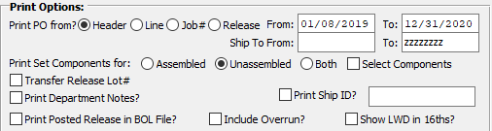

#### Print PO From? (Choice)

To choose the preferred PO layout, please make sure the desired option choice bubble is toggled.

#### Release From / Release To

Enter the beginning and ending Release Date to make Finished Good load tags for.

#### Ship-To From / Ship-To To

Enter the beginning and ending Ship-To Location to make Finished Good load tags for.

#### Print Set Components For (Choice)

To choose the preferred component set of Assembled vs. Unassembled (Or Both), please make sure the desired option choice bubble is toggled.

#### Select Components – Toggle Box

To print only select components, make sure that the Select Components toggle box is checked.

#### Transfer Release Lot # – Toggle Box

To transfer a release lot #, make sure that the Transfer Release Number toggle box is checked.

#### Print Department Notes? – Toggle Box

To print department notes, make sure that the Print Department Notes toggle box is checked.

#### Print Posted Release in BOL File? – Toggle Box

To print a posted release in the bill of lading file, make sure that this toggle box is checked.

#### Print Ship ID? – Toggle Box

To print a ship ID, make sure that the Print Ship ID toggle box is checked.

#### Ship ID

Enter the Ship ID number for the customer.

#### Include Overrun? – Toggle Box

To include overruns, make sure that the Include Overrun toggle box is checked.

#### Show LWD in 16ths? – Toggle Box

To show the LWD in 16ths, make sure that this toggle box is checked.

### Output Options

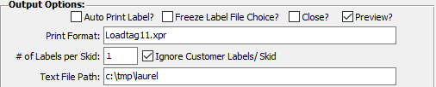

#### Auto Print Label? – Toggle Box

To automatically print the label after creation, make sure that the Auto Print Label toggle box is checked.

#### Freeze Label File Choice? – Toggle Box

To freeze the label file choice, make sure that this toggle box is checked.

#### Close? – Toggle Box

To close this job after creating the load tag, make sure that the Close toggle box is checked.

#### Preview? – Toggle Box

To preview the load tag before printing, make sure that the Preview toggle box is checked.

#### Print Format

Enter a file name and extension code for the created load tag.

#### Ignore Customer Labels/Skid – Toggle Box

To ignore the customer labels, make sure that this toggle box is checked.

#### Text File Path

Enter the file path for a text file version of the created load tags for system reference.

## Make Raw Material Tags

### Overview

Load tags may be created from purchasing when raw materials are received. The receiving clerk will create load tags for the number of incoming pallets by pressing the “***PO Load Tag”*** button. Each tag created will simultaneously create raw materials receipts in the Enter/Edit Receipts file. The top of the screen lists all the open purchase orders, whereas the bottom of the screen is a worksheet area for creating load tags for one or more items.

To create a load tag, select any item from the list of purchase orders by double clicking the item with the mouse. As an alternative the buttons on the right of the screen will allow selection of one or more items to be moved to the load tag worksheet section of the screen. Likewise, to remove items from the worksheet, double click the item or select the Remove all lines from Load tag or Delete selected lines from Load tag.

Once the item has been moved to the worksheet area, the number of tags, quantity per pallet and partial pallet quantity must be entered. For roll stock material, the program will prompt for the count, which is the quantity express by the consumption unit of measure.

The roll stock unit of measure options are MSF, LB, TON and LF, which represent per thousand feet, pound, ton and lineal feet respectively. Once the number of load tags and unit counts have been defined, the LOAD TAGS button is pressed to print the load tags. Each tag created will simultaneously create raw materials receipts in the Enter/Edit Receipts file.

Once the load tags are printed, they will be attached to each pallet. The load tag will show the purchase order number, item number, job number, unit count and a bar code load tag number, which is created by combining the purchase order number, line number, unit number and unit count for each pallet received. Alternatively, a vendor supplied load tag may be scanned, which will create the warehouse receipt. Receipts for materials without bar coded tags may be added via the “***Enter/Modify Receipts”*** button.

### Selection Parameters

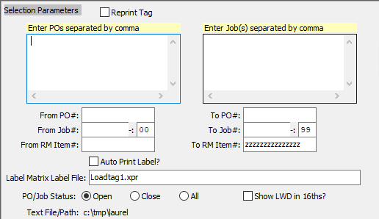

#### Reprint Tag – Toggle Box

If this is a reprint of an existing tag, make sure that the Reprint Tag toggle box is checked.

#### Enter PO’s Separated by Comma

If the purchase orders the user wishes to create load tags for are not sequential, the user may enter in the individual purchase orders they wish to create load tags for. Each must be separated by a comma.

#### Enter Job(s) Separated by Comma

If the jobs the user wishes to create load tags for are not sequential, the user may enter in the individual orders they wish to create load tags for. Each must be separated by a comma.

#### From PO # / To PO #

Enter the beginning and ending Purchase Order Number to make raw material tags for.

#### From Job # / To Job #

Enter the beginning and ending Job Number to make raw material tags for.

#### From Job #: 00 / To Job #: 00

Enter the beginning and ending Subsequent Job Number to make raw material tags for.

#### From RM Item # / To RM Item #

Enter the beginning and ending Raw Material Item Number to make raw material tags for.

#### Auto Print Label? – Toggle Box

To automatically print the label after creation, make sure that the Auto Print Label toggle box is checked.

#### Label Matrix Label File

The user must enter the file path of the Label Matrix Label File they wish to use to create these case labels. Alternatively, press the ***“F1”*** key to use the Windows Explorer window to choose the proper file path.

#### PO / Job Status (Choice)

The user can choose to create load tags for open orders, closed orders, or both open and closed orders. To choose the desired job status, please make sure that desired choice bubble is toggled.

#### Show LWD in 16ths? – Toggle Box

To show the LWD in 16ths, make sure that this toggle box is checked.

## Scan Case Label

### Overview

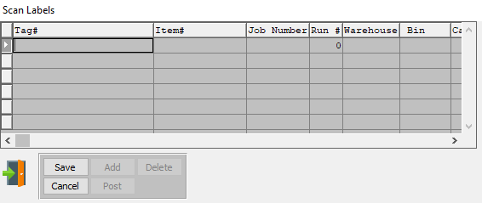

#### UPDATE

To change the currently selected XXX, simply click the ***“Update***” button at the bottom of the screen.

#### ADD

Click the ***“Add”*** button at the bottom of the screen to add a new Case Label.

#### DELETE

To delete the currently selected XXX, simply press the ***"D"*** key. Alternatively, click the ***“Delete”*** button at the bottom of the screen.

#### POST

To Post a Case Label record or batch, highlight each item with a single click, then press the “***POST”*** button at the bottom of the screen. Alternatively, the “***POST”*** button on the main menu may be used to post the entire batch of receipts, issues, transfers, adjustments and physic al counts.

#### EXIT

Click the ***“Exit Door Icon”*** to exit the Scan Labels popup screen.

### Add Case Label

#### SAVE

Click the ***“Save”*** button to save all changes to the current Case Label.

#### CANCEL

Click the ***“Cancel”*** button to cancel all changes to the Case Label without saving.

#### Tag #

Enter a Tag Number to search for. Alternatively, press the ***“F1”*** key to choose a valid Number from a list of available Tag Numbers.

#### Item #

Enter the Finished Good Item Number in this field. Alternatively, the Item Number field will automatically fill when the user selects their Tag Number.

The user can also press the ***“F1”*** key to search through all available Finished Goods items.

This list can be sorted by Item Number or Item Name. Alternatively, the user may search for any item that they wish to use in order to narrow down their selection.

Once an item is selected, this will automatically fill in several other fields with necessary information from the Item File.

#### Job Number

The job number defaults to the estimate number, but may be modified. The Job Factory Ticket will print by job number. Repeat jobs for an item will add a suffix to the original job number.

For example, a repeat job number could be Job number 88888-01 where 88888 is the original job and the 01 is the first repeat for that item.

All costs including, standard (estimated) labor, material and overhead, work in process, actual costs and variances are maintained by job number.

#### Run #

This is the run number for this Case Label.

#### Warehouse

This is the primary warehouse location for this item. The bin file will provide inventory control by warehouse, bin location and tag number. Enter the Primary Warehouse (loc). Alternatively, the user may press the ***“F1”*** key to select a warehouse from a list of available warehouses.

This list can be sorted by Location or Description. Alternatively, the user may search for any warehouse that they wish to use in order to narrow down their selection.

#### Bin

The bin location shows the location within the warehouse such as the aisle, bin location or floor location. Alternatively, the user may press the ***“F1”*** key to select the warehouse bin location information.

This list can be sorted by Warehouse or Bin. Alternatively, the user may search for any bin that they wish to use in order to narrow down their selection.

#### Case / Bundles-Pallet

Enter the quantity of cases per pallet. On number of cases are computed, the number of cases per pallet are calculated number of cases per pallet.

#### Pallet Count

This is the total number of pallets reserved for this warehouse location. This field can be compared to the total amount of pallets on hand inventory for that warehouse location to determine how much space is available for future inventory.

#### Qty / Case

The quantity of items per case.

#### Total Cases

This is the total number of cases for this label.

#### Qty

The total quantity of items.

#### Partial

Enter a partial quantity.

#### Receipt Date

Enter the date that the item was received, defaults to system date. This field automatically defaults to today’s date, but may be modified by the user.

## File Maintenance

### Overview

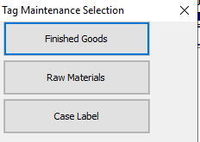

#### FINISHED GOODS

Click the ***“Finished Goods”*** button to open the *Finished Good Tag Maintenance Sharp Shooter* screen.

#### RAW MATERIALS

Click the ***“Raw Materials”*** button to open the *Raw Material tag Maintenance Sharp Shooter* screen.

#### CASE LABEL

Click the ***“Case Label”*** button to open the *Case Label Maintenance Sharp Shooter* screen.

### Finished Goods: Browse Load Tag

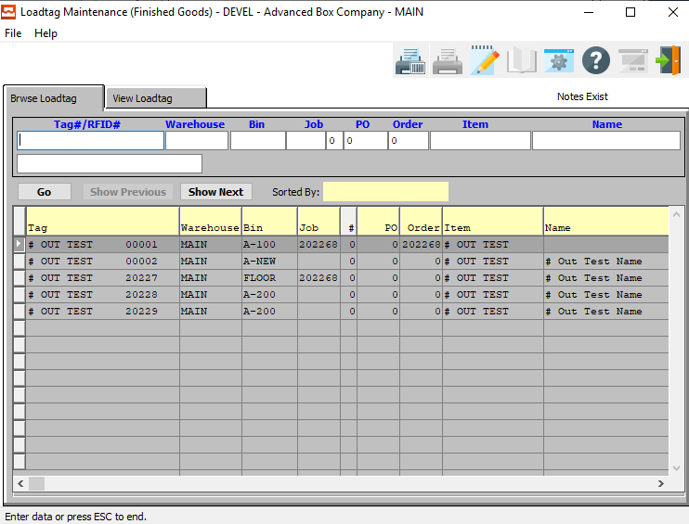

#### Tag # / Vendor Tag #

Enter a Tag Number to search for. Alternatively, press the ***“F1”*** key to choose a valid Number from a list of available Tag Numbers.

#### Warehouse

This is the primary warehouse location for this item. The bin file will provide inventory control by warehouse, bin location and tag number. Enter the Primary Warehouse (loc). Alternatively, the user may press the ***“F1”*** key to select a warehouse from a list of available warehouses.

This list can be sorted by Location or Description. Alternatively, the user may search for any warehouse that they wish to use in order to narrow down their selection.

#### Bin

The bin location shows the location within the warehouse such as the aisle, bin location or floor location. Alternatively, the user may press the ***“F1”*** key to select the warehouse bin location information.

This list can be sorted by Warehouse or Bin. Alternatively, the user may search for any bin that they wish to use in order to narrow down their selection.

#### Job #

The job number defaults to the estimate number, but may be modified. The Job Factory Ticket will print by job number. Repeat jobs for an item will add a suffix to the original job number.

For example, a repeat job number could be Job number 88888-01 where 88888 is the original job and the 01 is the first repeat for that item.

All costs including, standard (estimated) labor, material and overhead, work in process, actual costs and variances are maintained by job number.

#### Job #: 00

Repeat jobs for an item will add a suffix to the original job number.

#### PO #

This field is for the Order Number of Purchased Finished Goods only. The number entered must be a valid PO# from the ASI Purchasing Module. The user may enter a PO Number, or press the ***“F1”*** key to select the PO # from a list of all available Purchase Orders.

This list can be sorted by PO Number, Vendor Item, or Item Number. Alternatively, the user may search for a PO #, Vendor Item, or Item # that they wish to use in order to narrow down their selection.

#### Order #

Enter order number or you may use the ***“F1”*** key look-up. A partial description may be typed into any field or data may be entered into multiple fields followed by pressing the ***“Go”*** button to sort the fields by the criteria that was entered. Once the data is presented on the screen, the YELLOW column heading may be clicked to sort that specific column in ascending or descending order.

#### Item #

Enter the Finished Good Item Number in this field. Alternatively, the Item Number field will automatically fill when the user selects their Tag Number.

The user can also press the ***“F1”*** key to search through all available Finished Goods items.

This list can be sorted by Item Number or Item Name. Alternatively, the user may search for any item that they wish to use in order to narrow down their selection.

Once an item is selected, this will automatically fill in several other fields with necessary information from the Item File.

#### Item Name/Description

This description name transfers from the estimate for custom boxes, however it must be entered for stock boxes. This line transfers to the job ticket, purchase order, and numerous other reports. The system also uses the Item Name for alpha-Alphanumeric searches. This field will automatically populate once the user has selected or entered the item number, and cannot be modified further.

### Finished Goods: View Load Tag

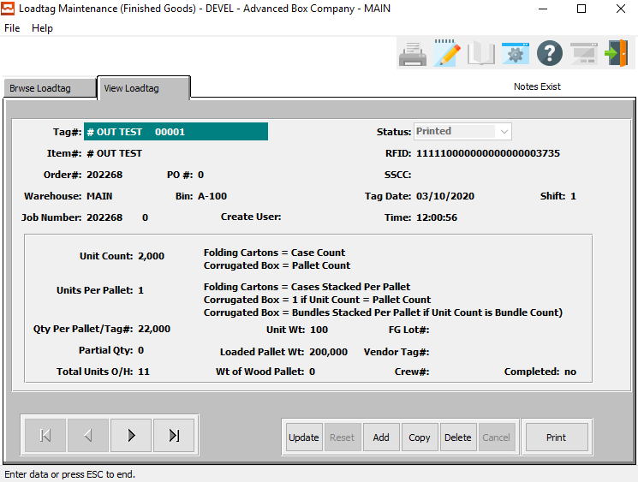

#### UPDATE

To change the currently selected Finished Good Load Tag, simply click the ***“Update***” button at the bottom of the screen.

#### ADD

Click the ***“Add”*** button at the bottom of the screen to add a new Finished Good Load Tag.

#### DELETE

To delete the currently selected Finished Good Load Tag, simply press the ***"D"*** key. Alternatively, click the ***“Delete”*** button at the bottom of the screen.

#### NEXT

Press ***"N"*** (Next) to find next Finished Good Load Tag to view or modify. Alternatively, press the ***“Right Arrow”*** on the screen.

#### PREVIOUS

Press ***"P"*** (Previous) to find previous Finished Good Load Tag to view or modify. Alternatively, press the ***“Left Arrow”*** on the screen.

#### PRINT

Click the ***“Print”*** button to print the currently selected Load Tag.

### Finished Goods: Add/Update Load Tag

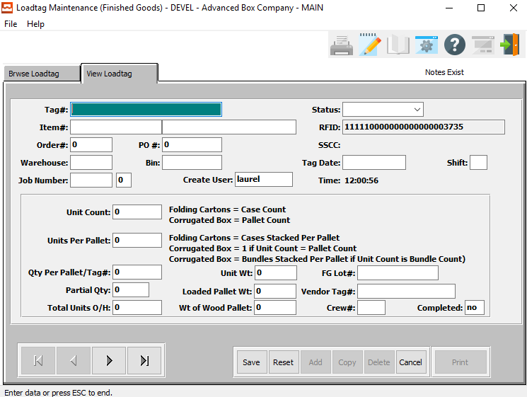

#### SAVE

Click the ***“Save”*** button to save all changes to the current Load Tag.

#### RESET

Click the ***“Reset”*** button to reset all fields to their original state.

#### CANCEL

Click the ***“Cancel”*** button to cancel all changes to the Load Tag without saving.

### Finished Goods: Add/Update Load Tag Field Definitions

#### Tag #

Enter a Tag Number to search for. Alternatively, press the ***“F1”*** key to choose a valid Number from a list of available Tag Numbers.

#### Status

The user may choose the current status of this Load Tag from the drop-down list of available options.

Valid Status are as Follows:

|  |  |  |  |
| --- | --- | --- | --- |
| Bill of Lading | Completed | Deleted | Invoiced |
| Issued | On-Hand | Printed | Received |
| Transferred |  |  |  |

#### Item #

Enter the Finished Good Item Number in this field. Alternatively, the Item Number field will automatically fill when the user selects their Tag Number.

The user can also press the ***“F1”*** key to search through all available Finished Goods items.

This list can be sorted by Item Number or Item Name. Alternatively, the user may search for any item that they wish to use in order to narrow down their selection.

Once an item is selected, this will automatically fill in several other fields with necessary information from the Item File.

#### Item Name/Description

This description name transfers from the estimate for custom boxes, however it must be entered for stock boxes. This line transfers to the job ticket, purchase order, and numerous other reports. The system also uses the Item Name for alpha-Alphanumeric searches. This field will automatically populate once the user has selected or entered the item number, and cannot be modified further.

#### Order #

Enter order number or you may use the ***“F1”*** key look-up. A partial description may be typed into any field or data may be entered into multiple fields followed by pressing the ***“Go”*** button to sort the fields by the criteria that was entered. Once the data is presented on the screen, the YELLOW column heading may be clicked to sort that specific column in ascending or descending order.

#### PO #

This field is for the Order Number of Purchased Finished Goods only. The number entered must be a valid PO# from the ASI Purchasing Module. The user may enter a PO Number, or press the ***“F1”*** key to select the PO # from a list of all available Purchase Orders.

This list can be sorted by PO Number, Vendor Item, or Item Number. Alternatively, the user may search for a PO #, Vendor Item, or Item # that they wish to use in order to narrow down their selection.

#### Warehouse

This is the primary warehouse location for this item. The bin file will provide inventory control by warehouse, bin location and tag number. Enter the Primary Warehouse (loc). Alternatively, the user may press the ***“F1”*** key to select a warehouse from a list of available warehouses.

This list can be sorted by Location or Description. Alternatively, the user may search for any warehouse that they wish to use in order to narrow down their selection.

#### Bin

The bin location shows the location within the warehouse such as the aisle, bin location or floor location. Alternatively, the user may press the ***“F1”*** key to select the warehouse bin location information.

This list can be sorted by Warehouse or Bin. Alternatively, the user may search for any bin that they wish to use in order to narrow down their selection.

#### Job Number

The job number defaults to the estimate number, but may be modified. The Job Factory Ticket will print by job number. Repeat jobs for an item will add a suffix to the original job number.

For example, a repeat job number could be Job number 88888-01 where 88888 is the original job and the 01 is the first repeat for that item.

All costs including, standard (estimated) labor, material and overhead, work in process, actual costs and variances are maintained by job number.

#### Job #: 00

Repeat jobs for an item will add a suffix to the original job number.

#### Create User

The username of the original user that created this receipt in the system.

#### Unit Count

Enter the number of units received of the item into this bin in this warehouse.

#### Units Per Pallet

Enter the number of units per pallet.

#### Qty Per Pallet / Tag #

Enter the quantity of individual units for this pallet or tag number.

#### Partial Qty

Enter a partial quantity.

#### Total Units O/H

Enter the total number of units on hand.

#### Unit Weight

Enter the weight of an individual unit that is to be placed upon the pallet.

#### Loaded Pallet Weight

This is the total weight of the pallet once it has been loaded, including the initial weight of the empty pallet.

#### Weight of Wood Pallet

Enter the initial weight of the wooden pallet before any items have been placed upon it.

#### FG Lot #

Enter the lot number for this Finished Good

#### Vendor Tag #

Enter a unique tag number for this Finished Good receipt.

A Warning Message should appear if the Tag Number already exists. This must be a unique number, otherwise the issue program will not know this tag number to select. The system now allows the user to enter the PO#, Line #, Qty, and then it duplicates the vendor tag #.

Alternatively, press the ***“F1”*** key to choose a valid Number from a list of available Tag Numbers.

#### Crew #

The crew size will default from the machine file. However, it may be modified by the user.

#### Completed Status

The user may choose the completion status for this load tag in this field. The user may enter either ***“Yes”*** or ***“No”***, any other entries are invalid.

### Raw Materials: Browse Load Tag

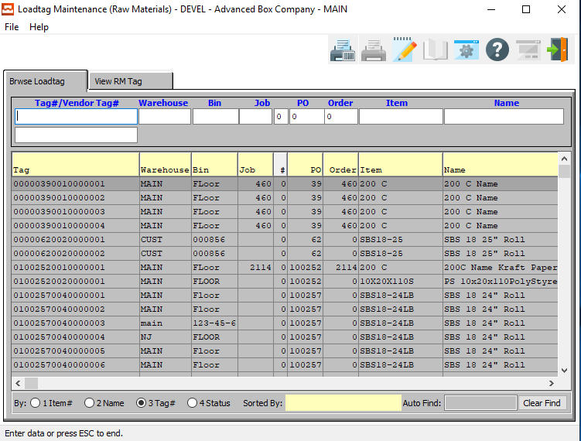

#### Tag # / Vendor Tag #

Enter a Tag Number to search for. Alternatively, press the ***“F1”*** key to choose a valid Number from a list of available Tag Numbers.

#### Warehouse

This is the primary warehouse location for this item. The bin file will provide inventory control by warehouse, bin location and tag number. Enter the Primary Warehouse (loc). Alternatively, the user may press the ***“F1”*** key to select a warehouse from a list of available warehouses.

This list can be sorted by Location or Description. Alternatively, the user may search for any warehouse that they wish to use in order to narrow down their selection.

#### Bin

The bin location shows the location within the warehouse such as the aisle, bin location or floor location. Alternatively, the user may press the ***“F1”*** key to select the warehouse bin location information.

This list can be sorted by Warehouse or Bin. Alternatively, the user may search for any bin that they wish to use in order to narrow down their selection.

#### Job #

Enter a job number to search for. Alternatively, press the ***“F1”*** key to choose a number from a list of available Job Numbers.

#### Job #: 00

Enter a subsequent job number to search for.

#### PO #

Enter a purchase order number to search for. Alternatively, press the ***“F1”*** key to choose a number from a list of available Job Numbers.

#### Order #

Enter order number or you may use the ***“F1”*** key look-up. A partial description may be typed into any field or data may be entered into multiple fields followed by pressing the ***“Go”*** button to sort the fields by the criteria that was entered. Once the data is presented on the screen, the YELLOW column heading may be clicked to sort that specific column in ascending or descending order.

#### Item #

Enter an item number to search for. Alternatively, press the ***“F1”*** key to choose a number from a list of available Job Numbers.

#### Item Name/Description

The item name/description will automatically transfer from the Raw Material file as soon a the user enters or chooses a valid item number.

### Raw Materials: View RM Load Tag

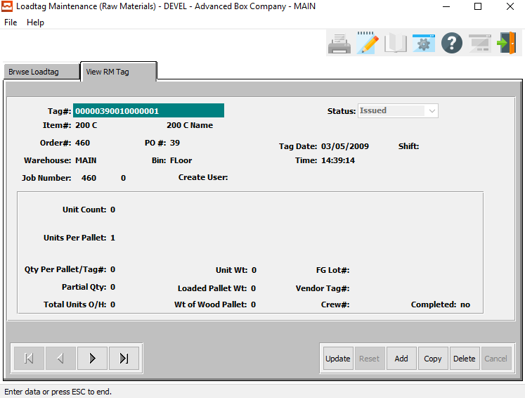

#### UPDATE

To change the currently selected Raw Material Load Tag, simply click the ***“Update***” button at the bottom of the screen.

#### ADD

Click the ***“Add”*** button at the bottom of the screen to add a new Raw Material Load Tag.

#### COPY

Click the ***“Copy”*** button to copy information from the currently selected Raw Material Load Tag.

#### DELETE

To delete the currently selected Raw Material Load Tag, simply press the ***"D"*** key. Alternatively, click the ***“Delete”*** button at the bottom of the screen.

#### NEXT

Press ***"N"*** (Next) to find next Raw Material Load Tag to view or modify. Alternatively, press the ***“Right Arrow”*** on the screen.

#### PREVIOUS

Press ***"P"*** (Previous) to find previous Raw Material Load Tag to view or modify. Alternatively, press the ***“Left Arrow”*** on the screen.

### Raw Materials: Add/Update RM Load Tag

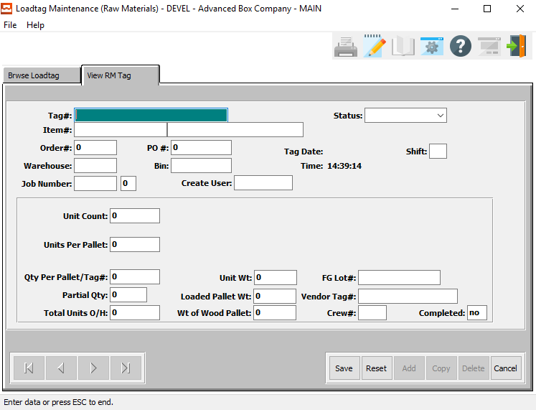

#### SAVE

Click the ***“Save”*** button to save all changes to the current Raw Material Tag.

#### RESET

Click the ***“Reset”*** button to reset all fields to their original state.

#### CANCEL

Click the ***“Cancel”*** button to cancel all changes to the Raw Material Tag without saving.

### Raw Materials: Add/Update RM Load Tag Field Definitions

#### Tag #

Enter a Tag Number to search for. Alternatively, press the ***“F1”*** key to choose a valid Number from a list of available Tag Numbers.

#### Status

#### Status

The user may choose the current status of this Load Tag from the drop-down list of available options.

Valid Status are as Follows:

|  |  |  |  |
| --- | --- | --- | --- |
| Bill of Lading | Completed | Deleted | Invoiced |
| Issued | On-Hand | Printed | Received |
| Transferred |  |  |  |

#### Item #

Enter the RM item number or you may use the ***“F1”*** look-up. A partial description may be typed into any field or data may be entered into multiple fields followed by pressing the ***“Go”*** button to sort the fields by the criteria that was entered.

#### Item Name/Description

This description name transfers from the estimate for custom boxes, however it must be entered for stock boxes. This line transfers to the job ticket, purchase order, and numerous other reports. The system also uses the Item Name for alpha-Alphanumeric searches. This field will automatically populate once the user has selected or entered the item number, and cannot be modified further.

#### Order #

Enter order number or you may use the ***“F1”*** key look-up. A partial description may be typed into any field or data may be entered into multiple fields followed by pressing the ***“Go”*** button to sort the fields by the criteria that was entered. Once the data is presented on the screen, the YELLOW column heading may be clicked to sort that specific column in ascending or descending order.

#### PO #

Enter a valid purchase order number. Alternatively, press the ***“F1”*** key to choose a number from a list of valid purchase orders.

#### Warehouse

This is the primary warehouse location for this item. The bin file will provide inventory control by warehouse, bin location and tag number. Enter the Primary Warehouse (loc). Alternatively, the user may press the ***“F1”*** key to select a warehouse from a list of available warehouses.

This list can be sorted by Location or Description. Alternatively, the user may search for any warehouse that they wish to use in order to narrow down their selection.

#### Bin

The bin location shows the location within the warehouse such as the aisle, bin location or floor location. Alternatively, the user may press the ***“F1”*** key to select the warehouse bin location information.

This list can be sorted by Warehouse or Bin. Alternatively, the user may search for any bin that they wish to use in order to narrow down their selection.

#### Job #

The job number defaults to the estimate number, but may be modified. The Job Factory Ticket will print by job number. Repeat jobs for an item will add a suffix to the original job number.

For example, a repeat job number could be Job number 88888-01 where 88888 is the original job and the 01 is the first repeat for that item.

All costs including, standard (estimated) labor, material and overhead, work in process, actual costs and variances are maintained by job number.

#### Job #: 00

Repeat jobs for an item will add a suffix to the original job number.

#### Create User

The username of the original user that created this receipt in the system.

#### Unit Count

Enter the quantity of cases.

#### Units Per Pallet

Enter the number of units per pallet.

#### Qty Per Pallet / Tag #

Enter the quantity of individual units for this pallet or tag number.

#### Partial Qty

Enter either a partial quantity.

#### Total Units O/H

Enter the total number of units on hand.

#### Unit Weight

Enter the weight of an individual unit that is to be placed upon the pallet.

#### Loaded Pallet Weight

This is the total weight of the pallet once it has been loaded, including the initial weight of the empty pallet.

#### Weight of Wood Pallet

Enter the initial weight of the wooden pallet before any items have been placed upon it.

#### FG Lot #

Enter the lot number for this Finished Good

#### Vendor Tag #

Enter a Tag Number to search for. Alternatively, press the ***“F1”*** key to choose a valid Number from a list of available Tag Numbers.

#### Crew #

The crew size will default from the machine file. However, it may be modified by the user.

#### Completed Status

The user may choose the completion status for this load tag in this field. The user may enter either ***“Yes”*** or ***“No”***, any other entries are invalid.

### Case Label: Browse Load Tag

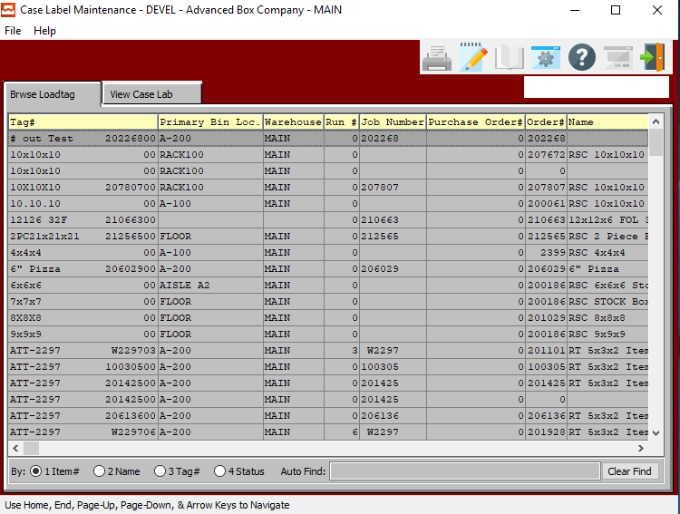

#### VIEW CASE LAB

Once the user has highlighted their desired Case Label to view detailed information for, they may click on the ***“View Case Lab”*** tab at the top of the screen. This tab allows the user to view detailed information, as well as update and add Case Labels.

### Case Label: View Case Label

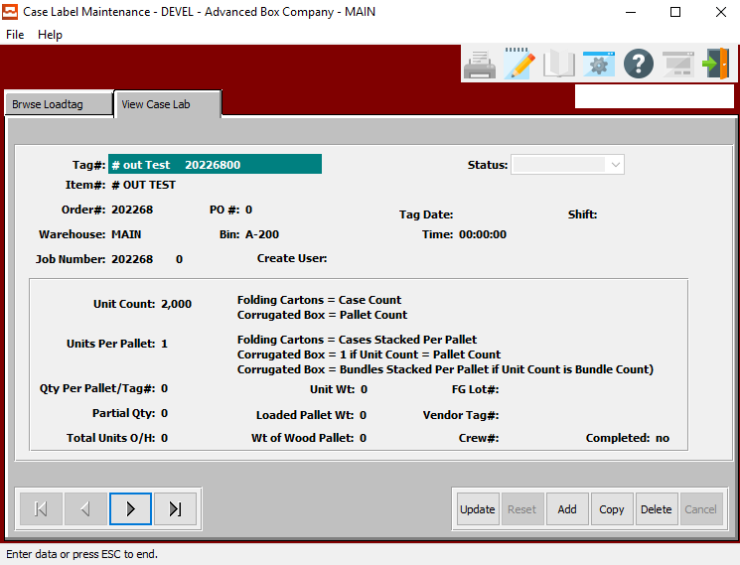

#### UPDATE

To change the currently selected Case Label, simply click the ***“Update***” button at the bottom of the screen.

#### ADD

Click the ***“Add”*** button at the bottom of the screen to add a new Case Label.

#### COPY

Click the ***“Copy”*** button to copy information from the currently selected Case Label.

#### DELETE

To delete the currently selected Case Label, simply press the ***"D"*** key. Alternatively, click the ***“Delete”*** button at the bottom of the screen.

#### NEXT

Press ***"N"*** (Next) to find next Case Label to view or modify. Alternatively, press the ***“Right Arrow”*** on the screen.

#### PREVIOUS

Press ***"P"*** (Previous) to find previous Case Label to view or modify. Alternatively, press the ***“Left Arrow”*** on the screen.

### Case Label: Add/Update Case Label

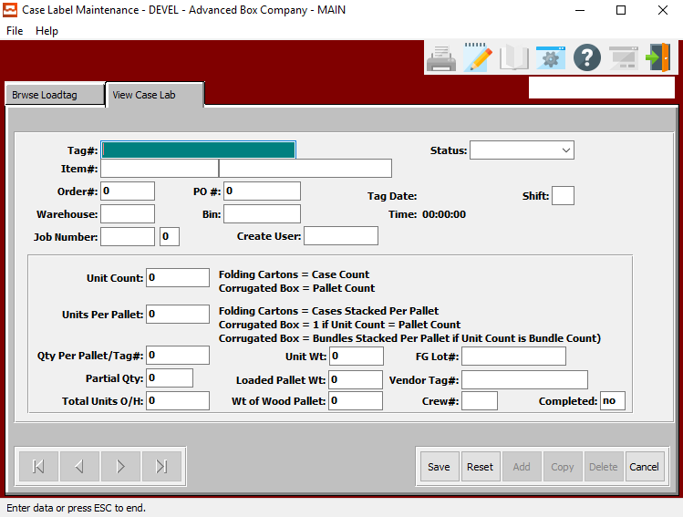

#### SAVE

Click the ***“Save”*** button to save all changes to the current Case Label.

#### RESET

Click the ***“Reset”*** button to reset all fields to their original state.

#### CANCEL

Click the ***“Cancel”*** button to cancel all changes to the Case Label without saving.

### Case Label: Add/Update Case Label Field Definitions

#### Tag #

Enter a Tag Number to search for. Alternatively, press the ***“F1”*** key to choose a valid Number from a list of available Tag Numbers.

#### Status

The user may choose the current status of this Load Tag from the drop-down list of available options.

Valid Status are as Follows:

|  |  |  |  |
| --- | --- | --- | --- |
| Bill of Lading | Completed | Deleted | Invoiced |
| Issued | On-Hand | Printed | Received |
| Transferred |  |  |  |

#### Item #

Enter the Finished Good Item Number in this field. Alternatively, the Item Number field will automatically fill when the user selects their Tag Number.

The user can also press the ***“F1”*** key to search through all available Finished Goods items.

This list can be sorted by Item Number or Item Name. Alternatively, the user may search for any item that they wish to use in order to narrow down their selection.

Once an item is selected, this will automatically fill in several other fields with necessary information from the Item File.

#### Item Name/Description

This description name transfers from the estimate for custom boxes, however it must be entered for stock boxes. This line transfers to the job ticket, purchase order, and numerous other reports. The system also uses the Item Name for alpha-Alphanumeric searches. This field will automatically populate once the user has selected or entered the item number, and cannot be modified further.

#### Order #

Enter order number or you may use the ***“F1”*** key look-up. A partial description may be typed into any field or data may be entered into multiple fields followed by pressing the ***“Go”*** button to sort the fields by the criteria that was entered. Once the data is presented on the screen, the YELLOW column heading may be clicked to sort that specific column in ascending or descending order.

#### PO #

This field is for the Order Number of Purchased Finished Goods only. The number entered must be a valid PO# from the ASI Purchasing Module. The user may enter a PO Number, or press the ***“F1”*** key to select the PO # from a list of all available Purchase Orders.

This list can be sorted by PO Number, Vendor Item, or Item Number. Alternatively, the user may search for a PO #, Vendor Item, or Item # that they wish to use in order to narrow down their selection.

#### Warehouse

This is the primary warehouse location for this item. The bin file will provide inventory control by warehouse, bin location and tag number. Enter the Primary Warehouse (loc). Alternatively, the user may press the ***“F1”*** key to select a warehouse from a list of available warehouses.

This list can be sorted by Location or Description. Alternatively, the user may search for any warehouse that they wish to use in order to narrow down their selection.

#### Bin

The bin location shows the location within the warehouse such as the aisle, bin location or floor location. Alternatively, the user may press the ***“F1”*** key to select the warehouse bin location information.

This list can be sorted by Warehouse or Bin. Alternatively, the user may search for any bin that they wish to use in order to narrow down their selection.

#### Job Number

The job number defaults to the estimate number, but may be modified. The Job Factory Ticket will print by job number. Repeat jobs for an item will add a suffix to the original job number.

For example, a repeat job number could be Job number 88888-01 where 88888 is the original job and the 01 is the first repeat for that item.

All costs including, standard (estimated) labor, material and overhead, work in process, actual costs and variances are maintained by job number.

#### Job #: 00

Repeat jobs for an item will add a suffix to the original job number.

#### Create User

The username of the original user that created this receipt in the system.

#### Unit Count

Enter the number of units received of the item into this bin in this warehouse.

#### Units Per Pallet

Enter the number of units per pallet.

#### Qty Per Pallet / Tag #

Enter the quantity of individual units for this pallet or tag number.

#### Partial Qty

Enter a partial quantity.

#### Total Units O/H

Enter the total number of units on hand.

#### Unit Weight

Enter the weight of an individual unit that is to be placed upon the pallet.

#### Loaded Pallet Weight

This is the total weight of the pallet once it has been loaded, including the initial weight of the empty pallet.

#### Weight of Wood Pallet

Enter the initial weight of the wooden pallet before any items have been placed upon it.

#### FG Lot #

Enter the lot number for this Finished Good

#### Vendor Tag #

When the Tag Number is scanned, this transfers to the PO#, PO Line# and Qty Fields. The Unit of Measure imports from the raw materials consumption unit of measure.

The RM Bar Code Tag format will be 999999 999 99999 99999 without any spaces.

* The first 6 digits represent the ASI PO#.
* The next 3 digits represent the ASI PO Line#.
* The last 5 digits represent the quantity on the roll or pallet.
* The last 5 digits represent the unique tag number.

A Warning Message should appear if the Tag Number already exists. This must be a unique number, otherwise the issue program will not know this tag number to select. The system now allows the user to enter the PO#, Line #, Qty, and then it duplicates the vendor tag #.

Alternatively, press the ***“F1”*** key to choose a valid Number from a list of available Tag Numbers.

#### Crew #

The crew size will default from the machine file. However, it may be modified by the user.

#### Completed Status

The user may choose the completion status for this load tag in this field. The user may enter either ***“Yes”*** or ***“No”***, any other entries are invalid.

# **Reports for Sharp Shooter Report [BR]**

## Production Report [BR1]

### Selection Parameters

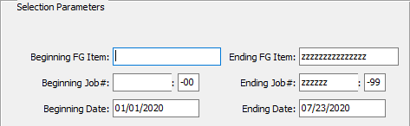

#### Beginning FG Item / Ending FG Item

Enter the beginning and ending Finished Good Item Number to run the Sharp Shooter report for.

#### Beginning Job # / Ending Job #

Enter the beginning and ending Job Number to run the Sharp Shooter report for.

#### Beginning Job #: 00 / Ending Job #: 00

Enter the beginning and ending Subsequent Job Number to run the Sharp Shooter report for.

#### Beginning Date / Ending Date

Enter the beginning and ending Job Date to run the Sharp Shooter report for.

### Output Destination

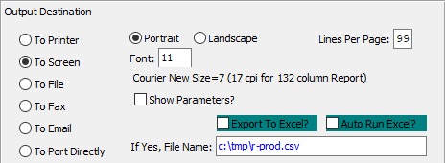

#### Destination Choice

To choose the destination where the document should be printed, please make sure that desired output destination choice bubble is toggled.

#### Layout Choice

To choose the preferred layout of Landscape vs. Portrait, please make sure the desired option choice bubbled is toggled.

#### Lines Per Page

Lines per page on the report when printing.

#### Font

Enter the font number to use with this report (Font 11 is default).

#### Show Parameters? – Toggle Box

To show parameters, make sure that the toggle box is ‘ticked’ with a checkmark.

#### Export to Excel? – Toggle Box

To export the printed file to an excel document, make sure that the Export to Excel toggle box is checked.

#### Auto Run Excel? – Toggle Box

To automatically open the new excel document, make sure that the Auto Run Excel toggle box is checked.

#### If Yes, File Name

If exporting the file to Excel, enter the desired file name.

# **Sharp Shooter Inquiry [BQ]**

## Job Attachments [BQ1]

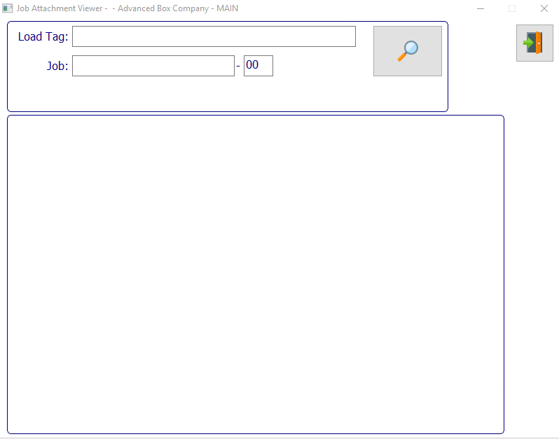

#### EXIT

Click the ***“Exit Door Icon”*** to exit the Job Attachments popup screen.

#### SEARCH

Click the ***“Magnifying Glass Icon”*** button in order to initiate a system search based on the user-given parameters.

#### Load Tag

Enter a load tag number to search for.

#### Job #

Enter a job number to search for.

#### Job #: 00

Enter a subsequent job number to search for.